Particle-into-Liquid Sampler
Instrument Handbook

TB Watson

March 2016

DISCLAIMER
This report was prepared as an account of work sponsored by the U.S. Government. Neither the United States nor any agency thereof, nor any of their employees, makes any warranty, express or implied, or assumes any legal liability or responsibility for the accuracy, completeness, or usefulness of any information, apparatus, product, or process disclosed, or represents that its use would not infringe privately owned rights. Reference herein to any specific commercial product, process, or service by trade name, trademark, manufacturer, or otherwise, does not necessarily constitute or imply its endorsement, recommendation, or favoring by the U.S. Government or any agency thereof. The views and opinions of authors expressed herein do not necessarily state or reflect those of the U.S. Government or any agency thereof.

Particle-into-Liquid Sampler
Instrument Handbook

TB Watson, Brookhaven National Laboratory

March 2016

Work supported by the U.S. Department of Energy,
Office of Science, Office of Biological and Environmental Research

Acronyms and Abbreviations
AAF ARM Aerial Facility
ARM Atmospheric Radiation Measurement Climate Research Facility
BDL data descriptor indicating “Below Detection Limit”
G-1 Gulfstream-1 aircraft
IC ion chromatographs
IOP intensive operational period
MAOS Mobile Aerosol Observing System
M-ohm mega-ohm
NG data descriptor indicating “No Good”
PILS Particle-into-Liquid Sampler
TOC total organic carbon

Contents
Acronyms and Abbreviations iii
1.0 Instrument Title 1
2.0 Mentor Contact Information 1
3.0 Vendor/Developer Contact Information 1
3.1 PILS Extraction Unit 1
3.2 Ion Chromatographs 1
3.3 Total Organic Carbon Analyzer 2
4.0 Instrument Description 2
5.0 Measurements Taken 3
5.1 Inorganic Ionic Species 3
5.2 Organic Ionic Species 3
5.3 Total Organic Carbon 3
6.0 Data Object Description 4
6.1 Mass Calculation 4
6.2 Data Ordering 5
7.0 Technical Specification 5
7.1 Ion Chromatographs 5
7.2 Total Organic Carbon 5
7.3 Units 5
7.4 Accuracy 6
7.4.1 Ion Chromatographs 6
7.4.2 Total Organic Carbon Detector 6
7.5 Limits of Detection 6
8.0 Instrument System Functional Diagram 6
9.0 Instrument/Measurement Theory 7
10.0 Operation of Instrument 7
11.0 Software 7
12.0 Calibration 8
12.1 Ion Chromatography 8
12.2 Total Organic Carbon 10
12.3 Calibration Frequency 11
12.3.1 Ion Chromatographs 11
12.3.2 Total Organic Carbon 11
13.0 Inlet System 11
14.0 Maintenance 12
14.1 Solutions 12
14.2 Peristaltic Pump Tubing 12
14.3 Columns 12
14.4 Denuders 13
15.0 Safety 13
16.0 Citable References 13

Figures
1. PILS aerosol extraction unit. 2
2. Individual data points (red crosses) and the padded (black line) data for SO₄ data during Flight 3 on July 14, 2012. 4
3. Schematic of the instrument configured to measure ions. 6
4. Schematic of the aerosol extraction unit (taken from Orsini et al. 2003). 7
5. Schematic of MAOS C inlet system including the sample line supplying the PILS. 9
6. Calibration curve for NH₄ determined from averages of a total of 61 points at concentrations of 1, 2, 3, and 4 mM. 10
7. AOS instrument enclosure with 10-m sampling stack. 11

Tables
1. Ions detected by the PILS 3
2. Compounds used to calibrate the ICs, their molecular weights, and the masses used in preparation of the primary standards at 100 and 50 mM. 10
3. Nominal concentrations of final ion standards and volume of intermediate standard used. 10
4. Solutions needed to operate the ion chromatographs. 12

Instrument Title
Particle-into-Liquid Sampler

Mentor Contact Information
Thomas B. Watson
Brookhaven National Laboratory
Environmental and Climate Sciences Department
Building 815E
Upton, NY 11973
Phone: (631) 344-4517
Fax: (631) 344-2887
E-mail: twatson@bnl.gov

Vendor/Developer Contact Information

PILS Extraction Unit
Applikon Analytical B.V.
De Brauwweg 13, P.O. Box 149,
3100 AC Schiedam
The Netherlands
Phone: +31 10 298 35 55
Fax: +31 10 437 96 48
E-mail: analyzers@applikon.com

Ion Chromatographs
Metrohm
6555 Pelican Creek Circle
Riverview, FL 33578
Phone: (866) 638-7646
http://www.metrohmusa.com/en-us

Total Organic Carbon Analyzer
GE Power and Water Process Technologies
6060 Spine Road
Boulder, CO 80301
Main: (303) 444-2009
Main (toll-free): (800) 255-6964
Technical Support: (888) 245-2595
Main: (303) 444-9543
Sales: (303) 444-9543
Orders: (303) 527-1797
Service: (303) 444-6272
geai@ge.com

Instrument Description
The Particle-into-Liquid Sampler (PILS) is an aqueous-solution-based online technique for determining bulk chemical composition of ambient aerosol particles. As shown in Figure 1, the instrument consists of two units, briefly described below:
  - An aerosol extraction unit where particles are passed through a growth chamber saturated with water vapor, liquid droplets are grown, and the resulting liquid collected and transferred to the detection system.
  - The detection system that includes ion chromatographs (IC) or a total organic carbon detector (TOC).
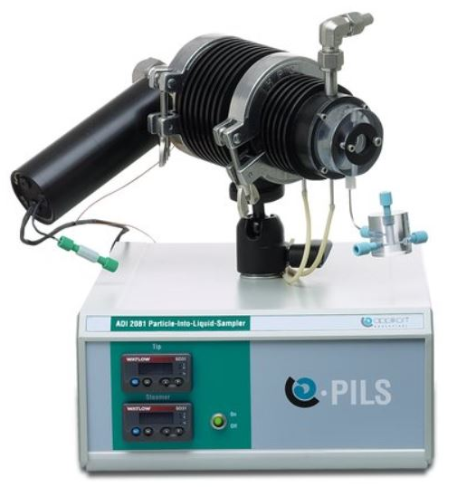
Figure 1. PILS aerosol extraction unit.
Ion chromatography is performed using two Metrohm ICs—one for positive ions and one for negative ions—with conductivity detectors.
The TOC is detected using a GE TOC analyzer.
The instrument can be run in either the ion detection mode or the TOC mode.

Measurements Taken

Inorganic Ionic Species
The PILS measures the following particulate ionic inorganic species: NH₄⁺, Na⁺, Li⁺, Mg²⁺, K⁺, Ca²⁺, SO₄²⁻, NO₃⁻, Cl⁻, Br⁻, and H₂PO₄³⁻.

Organic Ionic Species
The PILS measures the following particulate ionic organic species: HCO₂⁻, CH₃CO₂⁻, CH₃SO₃⁻, and C₂O₄²⁻.
The ions and their approximate retention times detected by the PILS using the Metrohm ICs are given in Table 1.
Table 1. Ions detected by the PILS
Ion | Retention Time
Li | 0.80
Na | 1.83
NH₄ | 2.36
K | 3.98
Mg | 12.60
Ca | 13.20
Cl | 1.91
Br | 4.26
NO₃ | 9.04
PO₄ | 9.04
SO₄ | 11.16
Oxalate | 13.17

Total Organic Carbon
The PILS measures particulate TOC when used with the GE TOC detector.

Data Object Description
Data are presented in text files in the following formats:
Column 1: UTC Time yyyy/mm/dd hh:mm:ss
Column 2–24: Ion_flag Data descriptor indicating below detection limit (BDL) or no good (NG) or text concentration value in µg/m³ with all calculated digits (not all significant)
Column 3–25: Ion_conc Concentration value in µg m⁻³ with all digits significant. Blanks where data are BDL or NG
The reported time is corrected for the sample delay time. Even columns are in text format and contain data flags and numerical data that are not rounded to reflect significant figures. Odd columns contain ion concentration data in µg/m3 and are rounded to reflect significant figures. All concentrations are reported at ambient temperature and pressure.
Data are reported at 1-s intervals, but because there is only one data point taken by the PILS every
3 min in the aircraft and every15 min for the ground-based instrument, the reported data are padded so the time between every data point is filled with the same value. An example of this is given in Figure 2, which shows the individual data points and the padded data.
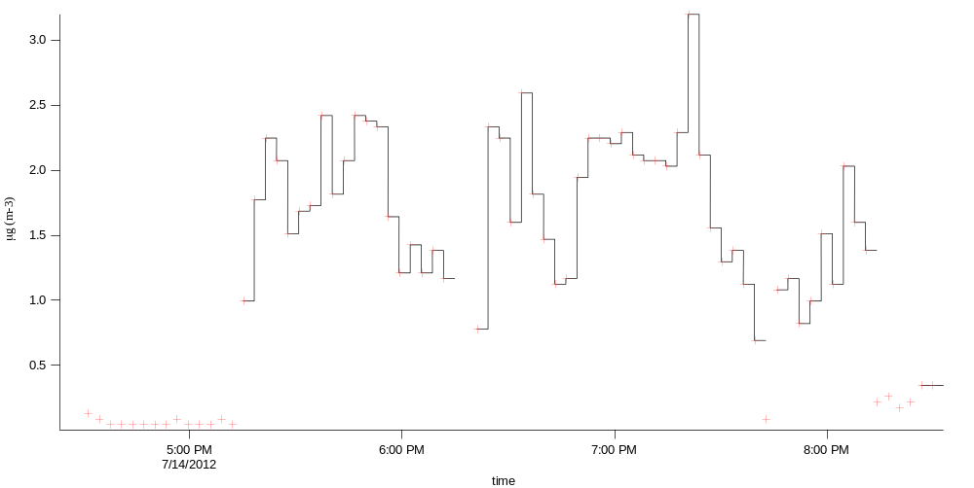
Figure 2. Individual data points (red crosses) and the padded (black line) data for SO₄ data during Flight 3 on July 14, 2012.

Mass Calculation
The concentration data determined from the chromatograms are converted into mass concentration of the aerosol at ambient pressure and temperature using the following expression.
[X]_{m} = [X]_{liq} × F_{liq} × M_{w} ÷ F_{air}
where:
[X]_{m} ≡ ion concentration in (µg/m³)
[X]_{liq} ≡ molar ion concentration
F_{liq} ≡ PILS carrier solution flow rate (L/min)
M_{w} ≡ molecular weight (µg/mole)
F_{air} ≡ flow rate of sample air through the PILS body (15 L/min at ambient conditions).

Data Ordering
Data ordering is addressed at http://www.arm.gov/xdc.

Technical Specification

Ion Chromatographs
- Time resolution
- 15min in the ground-based configuration
- 3 min in the aircraft-based configuration.
- Analysis time
- 14.5 min
- Aerosol particle diameter size range
- Approximately 70 nm to 2.5 µm

Total Organic Carbon
- Analysis time
- 4 min
- Range
- 0.03 ppb to 50 ppm

Units
µg/m³

Accuracy

Ion Chromatographs
The uncertainty associated with the mass measurements was estimated by combining the uncertainties in flow rates and IC calibrations. Uncertainties of both liquid and air flow rates are approximately 4%. Uncertainties in the IC calibration for sulfate, nitrate, and ammonium were determined by comparisons with measurements of independent traceable standards from the National Institute of Standards and Testing. Comparisons immediately following IC calibrations were within 3 to 5% and 5 to10% after running for an extended period. The overall uncertainty of the measured ionic species is estimated to be approximately 10% (Orsini et al. 2003).

Total Organic Carbon Detector
The Seivers TOC detector has an accuracy of ±2%.

Limits of Detection
- Anions: ~0.05 µg/m³
- Cations: ~0.1 µg/m³
- TOC: ~0.5 µg/m³

Instrument System Functional Diagram
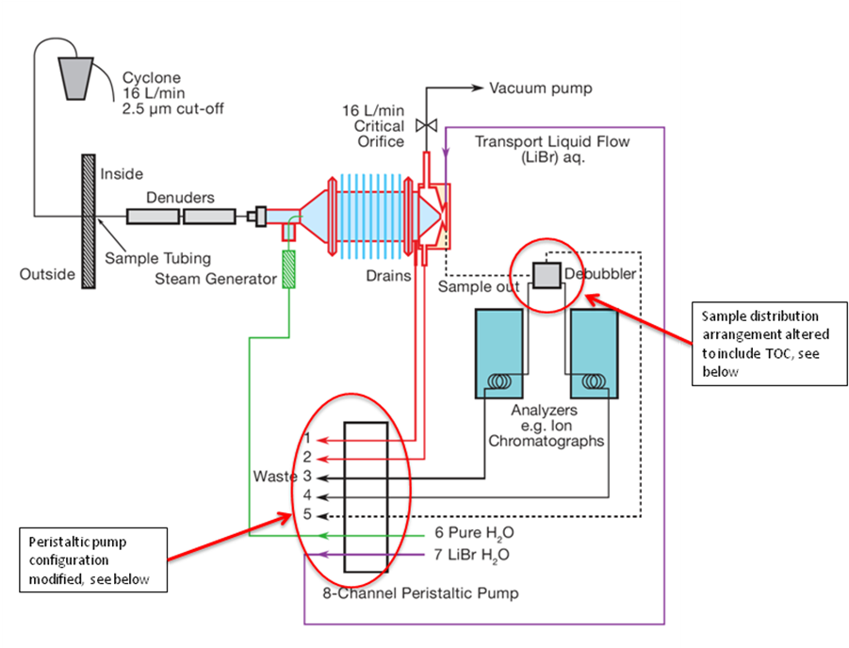
Figure 3. Schematic of the instrument configured to measure ions.

Instrument/Measurement Theory
Ambient air containing aerosol is drawn into the PILS growing chamber at approximately 15 L/min. There, the sample is mixed with a smaller, approximately 1.5 L/min, turbulent flow of 100ºC steam. The steam is cooled by mixing with the sample flow to create a condition in which the chamber is supersaturated with water vapor. In the supersaturated conditions, aerosol particles are activated and grow into droplets approximately1 µm and larger in diameter. The droplets are collected on a single-orifice impactor. The liquid sample collected on the impactor surface is removed using a small, constant flow of purified water that also contains an internal standard (Figure 4). This liquid sample is then analyzed using IC or TOC techniques to quantify the ionic species or TOC contained in aerosol particles. Because gas-phase compounds also are present in ambient air samples, gas-phase denuders are placed in the sample line upstream of the PILS aerosol extraction unit.
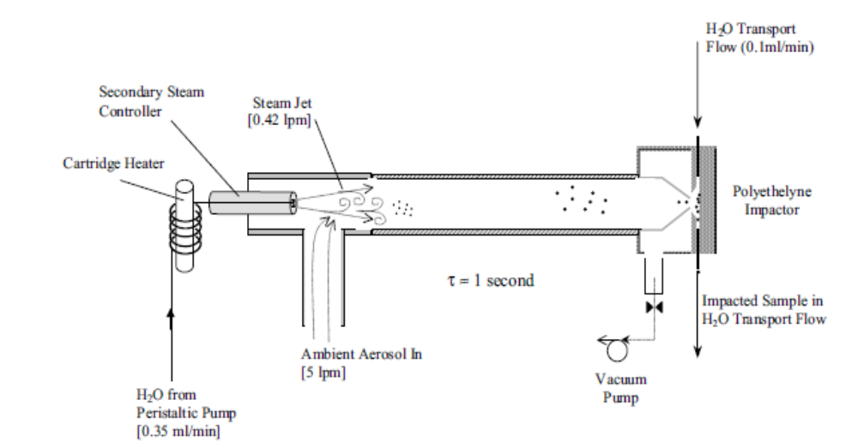
Figure 4. Schematic of the aerosol extraction unit (taken from Orsini et al. 2003).

Operation of Instrument
Currently, two PILS systems are operating at ARM facilities. One is located at the in the Mobile Aerosol Observing System (MAOS) (Figure 5), and the other is used as needed on the Gulfstream-1 (G-1) aircraft in support of field programs of the ARM Aerial Facility (AAF).

Software
The ICs are controlled by proprietary software, Magicnet IC, developed by Metrohm. This software is used to control the operation of the chromatographs and in data processing.

Calibration

Ion Chromatography
Calibration of the ICs is performed using standard solutions made from serial dilution of primary standards. The primary standards are made gravimetrically. Stock solutions are prepared at 0.1 or
0.05 M (±1%) using 18 M-ohm purified H2O in plastic 100-mL volumetric flasks. The compounds used for calibrating the ICs are given in Table 2. Serial dilution is then used to produce intermediate and final calibration standards. Concentrations of the final standard are given in Table 3. Intermediate and final calibration standards must be prepared immediately prior to each calibration to ensure accurate concentrations. The chemical degradation of low concentration solutions can occur if they are not used immediately. An example of a calibration curve is given in Figure 6.
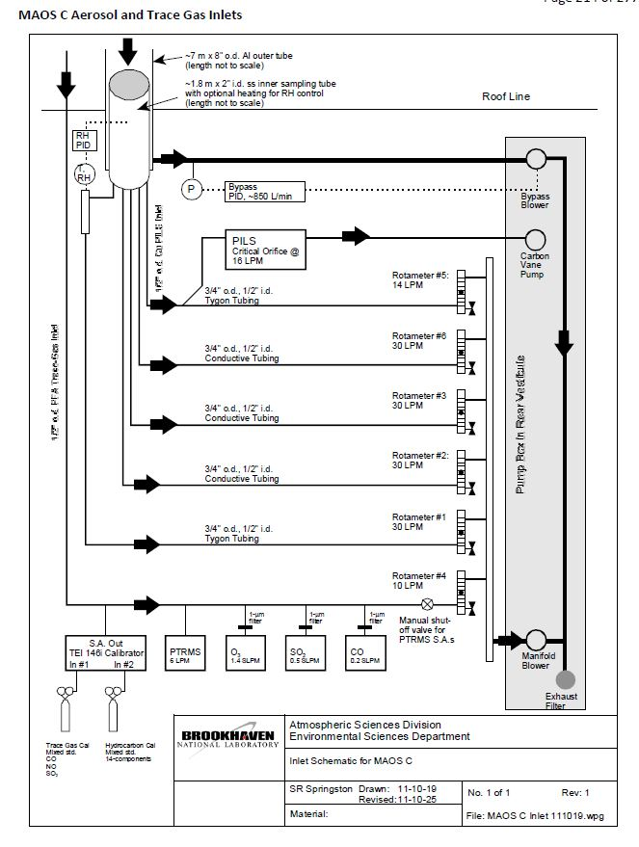
Figure 5. Schematic of MAOS C inlet system including the sample line supplying the PILS.
Table 2. Compounds used to calibrate the ICs, their molecular weights, and the masses used in preparation of the primary standards at 100 and 50 mM.
Chemical | M. W. | For 0.100 M, gm | For 0.05 M, gm
LiClO₄•3H₂O | 160.4 | 1.60 | 0.80
NaAct | 82.0 | 0.82 | 0.41
CaCl₂ | 111 | 1.11 | 0.55
KBr | 119 | 1.19 | 0.60
NH₄NO₃ | 80 | 0.80 | 0.40
KH₂PO₄ | 136 | 1.36 | 0.68
MgSO₄•7H₂O | 246.5 | 2.47 | 1.24
Na₂C₂O₄ | 134 | 1.34 | 0.67
Table 3. Nominal concentrations of final ion standards and volume of intermediate standard used.
Final Nominal Concentration, µM | Volume, µL
0.5 | 10
1 | 20
2 | 40
3 | 60
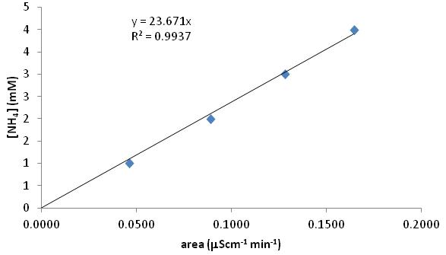
Figure 6. Calibration curve for NH₄ determined from averages of a total of 61 points at concentrations of 1, 2, 3, and 4 mM.

Total Organic Carbon
The total organic carbon detector is calibrated using certified reference materials containing potassium hydrogen phthalate and sodium carbonate. These standards are supplied by the instrument manufacturer.

Calibration Frequency

Ion Chromatographs
The ground-based ICs and TOC detector should be calibrated with a full range of standards at least once a week. The PILS operated on the aircraft should be calibrated at the end of every flight with at least one standard concentration.

Total Organic Carbon
The TOC should be calibrated before and after every intensive operational period (IOP) or once a month.

Inlet System
Ambient aerosol-laden air is brought to the instruments at 800 L/min through an 8-in. diameter external stack extending nominally 10 ft above the roof (Figure 7) of the enclosure. Inside the stack, sample air flows through a 2-in. diameter stainless-steel pipe in the center of this larger flow at 120 L/min. This flow is split inside the enclosure into four, 30-L/min sample lines, one of which supplies the PILS as well as other instruments. The proton transfer reaction mass spectrometer is connected to this line with a tee fitting. This line is insulated to prevent condensation in the line in the air-conditioned interior of the instrument enclosure.
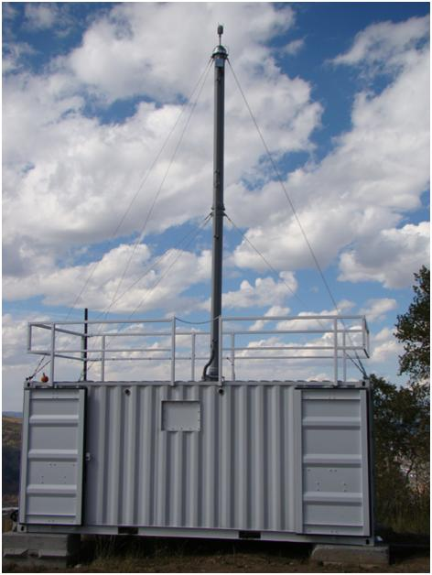
Figure 7. AOS instrument enclosure with 10-m sampling stack.

Maintenance

Solutions
Solutions necessary for operation of the PILS in the ionic measurement mode are given in Table 4. These solutions must be prepared with ultra-pure deionized water with a conductivity of 18 M-ohm.
Table 4. Solutions needed to operate the ion chromatographs.

 | Solution | Use | Content | Flow Rate  mL/min | Preparationª
1 | Purified H₂O | Steam H₂O supply and TOC background | Purified H₂O  (18 M-ohm cm  TOC <50 ppb) | 1.5 | 18 M-ohm H₂O from EasyPure II
2 | Carrier solution | For washing off aerosol sample from impactor | 2 µM LiClO₄ (internal standards) | 0.86
3 | Anion IC eluent | For anion column elution | 1.0 mM NaHCO₃ 3.2 mM Na₂CO₃ | 0.7 | One sachet of stock into 800 mL H₂O
4 | Cation IC eluent | For cation column elution | 2.5 mM oxalate | 0.7
5 | Anion IC suppressor solution 1 | For suppressing anion IC background signal | 100 mM H₂SO₄ | 0.06@ setting = 1 | available from Metrohm
6 | Anion IC suppressor solution 2 | For suppressing anion IC background signal | Purified H₂O | 0.06@ setting = 1 | Purified H₂O
7 | Calibration standards | For calibrating the ICs | 0.5-3.0 µM |  | Prepared from  1 mM intermediate standards
ª All solutions prepared from purified H₂O (ASTM Type 1)

Peristaltic Pump Tubing
Peristaltic pump tubing should be replaced before every IOP, or after 1 month of semi-continuous operation.

Columns
Columns should be replaced before every IOP or when they show signs of degradation. Symptoms of degradation are the appearance of spurious peaks or inadequately separated peaks when running calibration standards.

Denuders
The Honeycomb denuders are applied to remove acid and base gas species, including SO₂, HNO₃, and NH₃, to eliminate positive concentration biases of these soluble species to aerosol SO₄²⁻, NO₃⁻, and NH₄⁺. Two denuders are used in series to eliminate gas-phase compounds. The denuders are coated with:
- 1% (by weight) Na2CO3 in a solution of 1% glycerol in a 50% methanol/50% water mixture
- 2% citric acid in 1% glycerol in methanol.

Safety
Safety glasses, gloves, and lab coats should be used in the preparation of all operational and calibration solutions.

Citable References
Orsini, DA, Y Ma, A Sullivan, B Sierau, K Baumann, and RJ Weber. 2003. “Refinements to the particles into water sampler (PILS) for ground and airborne measurements of water soluble aerosol composition.” Atmospheric Environment 37(9-10):1243-1259, doi:10.1016/S1352-2310(02)01015-4.
Watson, TB. “TCAP 1 and 2 Particle-into-Liquid Sampler aircraft data.” Data report prepared for the TCAP program. Slide available at http://asr.science.energy.gov/meetings/stm/posters/poster_pdf/2013/P000998.pdf.

