ACRF/NSA

ATQASUK MET TOWER

OWNERS MANUAL

POINT OF CONTACT:

Michael T. Ritsche
Argonne National Laboratory
Building 203, Room J-175

Argonne, IL 60439-4843
Tel: (630) 252-1554
Fax: (630) 252-5498

Email: mtritsche@anl.gov
INTRODUCTION AND OVERVIEW

Surface meteorological data is collected at the ARM Climate Research Facility (ACRF) North Slope of Alaska (NSA) site at two locations, Barrow, Alaska and Atqasuk, Alaska. At the site in Atqasuk data is collected at the base of a 10-meter tip tower and at various heights on the tower. Temperature and relative humidity are collected at 2-meter and 5-meter while wind speed and direction are collected at 10-meter.

The data is collected at the base of the tower using a Campbell Scientific CR23X datalogger. The datalogger is polled once a minute by Campbell Scientific LoggerNet software. The LoggerNet software runs on a Dell Optiplex GX270 small form-factor computer using Microsoft XP Professional as the operating system. The computer system is configured such that if power is interrupted it will automatically restart eliminating the need for human intervention. The LoggerNet software has been added to the start menu so that it will automatically begin to collect data from the dataloggers as soon as the system has re-booted.

The data from the datalogger is stored in a single location and the data is appended to an ever-increasing file. A PERL script has been written to search the data file once an hour to capture a single hours worth of data (00 – 59) and copy the data to another file location with a unique time and date name. The file is then deleted preventing a large, single file that continues to grow. The hourly files created by the PERL script are collected once an hour using FTP and the collected file is then deleted from the local PC.

Remote Administrator (RAdmin) software has been loaded to the computer so that remote access is available for loading new programs, troubleshooting, etc. Access is limited to the site observers, mentors, and selected operations personnel.

Temperature, relative humidity (from two levels), wind speed and direction are collected once per second. The one-second analog data is collected by a Vaisala QLI data collector and is sent via serial cables to the CR23X datalogger once per second where it is accumulated to create one-minute averages and other calculated variables. Data is collected from the other sensors near the base of the tower once each minute. The Present Weather Sensor (PWS), Chilled Mirror Hygrometer (CMH) and barometric data are collected once per minute at each location. Data from each of the sensors at the base of the tower transmit their data via serial cable.

The serial data from all sensors is sent to, or requested by, a Campbell Scientific serial data multiplexer (SDM-SIO4). An SDM-SIO4 has four ports and a unique address so that multiple SDMs can be connected to each logger. The SDM contains programming for the communication protocols (baud rate, data bits, etc) and filters so data can be converted to a form the CR23X can accept.

The data collected by the logger is requested by the LoggerNet system once per minute. The data is sent by the CR23X datalogger to the computer via a network connection. A Campbell Scientific NL-100 network interface is used to send the data via an RS-232 serial connection from the logger to the computer. The NL-100 allows each datalogger to have a unique network address. The data is passed from the NL-100 to an Allied Telesyn AT-MC13 media converter via a Cat-5 Ethernet cable. The media converter sends the data via a fiber optic cable to another media converter inside the building where it is sent through a network switch and onto the computer. See Figure 1: Network Diagram.

The data that is collected from the datalogger can be viewed locally at each sites computer. A program contained in the LoggerNet software package called Real Time Monitor and Control (RTMC) is used to plot graphs of the data and view data values, allowing observers to verify proper operation of the system and sensors. The raw one-second data can also be viewed to assist in troubleshooting.

Dell Computer

Ethernet cable

Network Switch

SDS

Ethernet cable
Cat 5E straight
through
Media converter

Fiber Optic
Cable

Media converter converter

Ethernet cable
Cat 5E straight
through

NL100

NL100

NL100

RS232
cable

CR23X
Datalogger
CR23X
Datalogger
CR23X
Datalogger

SKYRAD GNDRAD MET

Figure 1: Network Diagram

SYSTEM COMPONENTS

METEOROLOGICAL SENSORS

Wind Speed Sensor

A Vaisala WAA251 cup anemometer is used to measure the horizontal wind. The anemometers have heated cups and shafts to prevent ice build up. The anemometers employ a photo-chopper to produce a 10 Hz per m/s signal. Vaisala quotes a starting threshold of <0.5 m/s, a distance constant of 2.7 m, and a linear output with an accuracy of +/- 0.17 m/s from 0.4 to 75 m/s.

Wind Direction Sensor

A Vaisala WAV151 wind vane with heated shaft is used to measure wind direction. The vanes use an optically detected GRAY code disk with a 5.6º resolution. Vaisala quotes a starting threshold of 0.4 m/s, a damping ratio of 0.14, and overshoot ratio of 0.65 and a delay distance of 0.4 m.

Temperature and Relative Humidity Sensor

A Vaisala HMP45D temperature and relative humidity probes are used to measure air temperature and relative humidity at multiple heights. The probes are mounted at 2m and 5m. Each probe contains a Vaisala HUMICAP sensor and associated electronics along with a 4-wire, platinum resistance temperature detector. The relative humidity output is an analog signal, with 0 to 1V corresponding to an RH of 0 to 100%. Vaisala quotes the accuracy of the RH signal to be +/- 2% for 0 to 90 % and +/- 3% for 90 to 100%. The RH sensor has a response time of 15 seconds. The long-term stability is quoted to be better than 1% RH per year and a temperature dependence of +/- 0.05% RH/ºC. The measurement range of the RTD is quoted as –40 to +60 ºC. Each temperature and relative humidity probe is mounted in a R.M. Young Model 43408-2 aspirated radiation shield. A brushless DC blower provides aspiration.
Ambient Temperature and Dew Point Temperature

A Technical Services Laboratory Model 1088 hygrothermometer (CMH) is used to measure air temperature and dew point. The sensor is mounted near the lowest level temperature and relative humidity probe at the base of the tower. The Model 1088 measures temperature and dew point over the range of –80 to +130º F. The accuracy of the temperature measurement is +/- 1º RMS in the range of –60 to +122º F and +/- 2º F RMS through the remainder of the range. The accuracy of the dew point temperature is +/- 2º F RMS from 30 to 86º F, +/- 3º F RMS from –10 to 30º F, +/- 4º F from –30 to -10º F. No accuracy data for the dew point measurement is available for the rest of the range. The model 1088 consists of two component units, the aspirator and the transmitter. The aspirator contains the dew point assembly and temperature sensor. All of the associated electronics are contained in the transmitter. Data is sent via RS-232 to the collection system when the sensor is polled.

Visibility and Precipitation Sensor

A Vaisala FD12P present weather sensor (PWS) is a microprocessor- controlled intelligent device that uses a forward scatter visibility meter, a capacitive rain detector, and a platinum resistance temperature detector to measure visibility and precipitation. The LED light source has a peak-radiated power of 40 mW. The visibility measurement is accurate to +/-10% for ranges between 10 and 10,000 m and +/- 20% for ranges between 10,000 and 50,000 m. The accuracy of the precipitation intensity measurement is +/-30% for the range of 0.5 to 20 mm/hr. The LED transmitted light intensity is monitored and used to compensate for temperature and aging effects. Data is sent via RS-232 to the collection system when the sensor is polled.

Barometric Pressure Sensor

A Vaisala PTB201A or a PTB220 digital barometer is used to measure the station pressure (not corrected to sea level). The barometer uses a Vaisala BAROCAP silicon capacitive absolute pressure sensor. Vaisala quotes the operating temperature as –40 to +60º C and the pressure measurement range as 500 to 1100 hPa. The total accuracy over the measurement range is given to be +/- 0.15 hPa. Data is sent via RS-232 to the collection system when the sensor is polled.

DATA COLLECTION SYSTEM

QLI50 Sensor Collectors

Vaisala QLI50 sensor collectors are used to collect data from the wind speed, wind direction, temperature and relative humidity probes. The QLI50s determine the frequency of the WAA-252 anemometer signals by measuring and averaging the time between pulses. The GRAY code output from the WAV-151 wind vanes is read and converted to angles. The QLI-50s supply a constant current to the HMP45D platinum resistance detectors and relative humidity circuitry, measure the returned voltages, and convert the voltages to temperatures and relative humidity values. The QLI50s also use the temperature and relative humidity data to calculate dew point temperatures. The QLI50s convert the analog data from the sensors to a digital format. The QLI50s send the data automatically once per second to a Campbell Scientific SDM-SI04 serial data multiplexer. The data is sent via RS-232 to the SDM. The QLI-50s are set for automatic messaging (AMES 1s) at one-second intervals. A Vaisala WHP25 supplies power to the QLI50s.

Power Supplies

Vaisala WHP25 power supplies are used to power the QLI50 sensor collectors, the HMP45D temperature relative humidity probes and the heating system for the wind speed and wind direction sensors. The output voltage of the WHP25s is 24VAC. AC to DC converters are used to power the aspirators which contain the temperature and relative humidity probes.

Serial Data Multiplexer

A Campbell Scientific serial data multiplexer (SDM-SI04) is used to collect data from the serial devices and serial sensors. The barometer, present weather sensor (PWS), chilled mirror hygrometer (CMH), and the QLI50 sensor collector send data to the SDM. The SDM converts the serial data it collects to a form the CR23X datalogger can understand using complex filters supplied by the user. The SDM stores complex commands required to request data from the smart serial devices such as the PWS, CMH and barometer. These commands are also user supplied. Each SDM has four serial ports that are independently configured to communicate with different sensors. At Atqasuk one SDM is used to communicate with the single QLI50, the PWS, CMH and barometer.
CR23X Datalogger

A Campbell Scientific CR23X datalogger is used to acquire and process the data collected by the SDM from the various sensors. Once per minute the datalogger prompts the SDM to request data from the PWS, CMH and barometer. The datalogger also requests the one-second data from the SDM at once-per-second intervals. The one-second data from the QLI50s are accumulated in the logger in order to calculate the one-minute data values and statistics. The one-minute data from the barometer and the PWS is stored while the CMH data is converted from Fahrenheit to Celsius and relative humidity is calculated from the Celsius temperature and dew point. Once-per-minute data is sent from the CR23X to the PC upon request. The data is sent via Ethernet through a Campbell Scientific NL-100 network interface, then to an Allied Telesyn media converter through which the data is sent to a partner media converter via fiber optic cable. Once the data reach the end of the fiber the media converter sends the data through Ethernet cable to a network switch and then on to the PC. The CR23X datalogger includes a 4 Mbyte extended memory option allowing the storage of over 2 million data points in the event of a communication outage. The datalogger has an extended temperature option giving it a valid operating temperature range of –40 to +60 C. The CR23X has been modified so that the Input/Output connectors are removable allowing for quick connect/disconnect for easy datalogger replacement.

NL-100 Network Link Interface

A Campbell Scientific NL-100 network interface is used to communicate with the Campbell Scientific CR23X datalogger. The NL100 uses an Ethernet 10 Base-T communications link between itself and the Allied Telesyn media converter. The NL100 is configured to act as a Serial Server in the TCP/IP network. The unique IP address for the system is stored within the NL100.
AT-MC13 Ethernet Media Converters

The AT-MC13 media converters are used to convert the data from the CR23X (through the NL100) to fiber optics. Converting to fiber optics and using the media converters allows for a 2Km maximum operating distance of the network. Two media converters are used; one is located at the base of the towers in the datalogger enclosure, the other is located inside the building at each location. The media converters operate at 10 Mbps and feature half- and full-duplex operation. The media converters also have a MIDI/MDI-X switch. This switch is used to configure the twisted pair port on the media converter as either MIDI or MIDI-X eliminating the need for crossover cables regardless of the type of network device that is connected to the unit. The media converters also have a Fiber Link Test switch that allows testing of the fiber optic connection without requiring the twisted pair port to be connected. See Figure 1 Network Diagram.

Computer

The PC is a Dell Optiplex GX270 Small Form Factor with a 15” flat panel monitor. The PC contains a Celeron 2.00 GHz, 400 Front Side Bus, and 128K Cache processor. It has 512mb of DDR non-ECC SD-RAM and an Integrated DVMT Video card. The hard drive is an 80 GB EIDE 7200 RPM drive. It also has internal Dell business audio speakers, an integrated Intel Gigabit (10/100/1000) network interface card and an 8x DVD-ROM. The operating system installed on the PC is Microsoft Windows XP Professional using NTFS. The PC was configured to conform to the ARM core PC requirements. The PC is configured to automatically restart and logon after power disruption eliminating the need for human intervention. Campbell Scientifics’ LoggerNet software is loaded on the PC and is configured to initialize at start up. LoggerNet is the software application that enables communication and control of the CR23X datalogger. Radmin software is also loaded on the PC allowing remote connection to or control of the local PC. A share-ware program called InternetTime is used to verify and adjust the time of the PC clock once a day. A PERL script called "split_working_cdl.pl" is used to handle the output data file from the LoggerNet software. This script resides in C:\ARM\bin and is scheduled to run once an hour in the LoggerNet task manager. This script creates uniquely named hourly files and places the files in a folder from which the Data Collection System can access, collect and delete them. FTP software allows the Data Collection System to access the PC.
LoggerNet

LoggerNet software is an application that allows the set up, configuration, and retrieval of data from a network of Campbell Scientific dataloggers. LoggerNet also allows sharing of data over an Ethernet communications network. LoggerNet is written using advanced “client-server” architecture. The server is a software program that runs in the background, handling all of the datalogger communications. The server also takes care of storing the data and providing information to manage the datalogger network. Client software programs in LoggerNet are used to create datalogger programs, view and graph data, verify communications on the network, and run other software or tasks.

MEASURED AND CALCULATED VARIABLES

The Atqasuk 10-meter meteorological tower consists of two levels of temperature and relative humidity data and one level of wind speed and direction data. The data from each of these sensors is collected by a QLI50 at the base of the tower. The measured and calculated data is sent once-per-second to the data logging system also at the base of the tower. Once-per-minute data from the chilled mirror hygrometer, the present weather sensor, and barometer is collected also. The one-second data is accumulated in the logger so that one-minute averages, other calculated variables, and statistics can be created. The LoggerNet software requests data from the logger once-per-second and stores it in C:\MetTipTowerData\MetTipTower.dat. This file is appended to continually. A PERL script running selects an hours worth of the one-minute files, copies it to another location and deletes the file (See Figure 2: PERL Script). The following table is a list of the one-minute variable names, their units, and their common names for the Atqasuk system.

Table 2: Atqasuk one-minute data
Variable # | Label | Units | Common Name
1 | 1 | N/A | Array ID
2 | Year_RTM | N/A | Year
3 | Day_RTM | N/A | J-day
4 | Hour_Minute_RTM | N/A | Hour/minute
5 | WinSpeed_S_WVT | m/s | Arithmetic mean wind speed
6 | WinSpeed_U_WVT | m/s | Vector averaged wind speed
7 | WinDir_DU_WVT | degree | Vector averaged wind direction
8 | WinDir_SDU_WVT | degree | St dev of vector averaged wind direction
9 | Tupper_AVG | Celsius | 5m Temp Avg
10 | RHupper_AVG | % | 5m RH Avg
11 | DPupper_AVG | Celsius | 5m Calc Dew Point Avg (5m)
12 | Tlower_AVG | Celsius | 2m Temp Avg
13 | RHlower_AVG | % | 2m RH Avg
14 | DPlower_AVG | Celsius | 2m Calc Dew Point Avg
15 | VP5m_AVG | kPa | 5m Calc Saturation Vap Pres Avg
16 | VP2m_AVG | kPa | 2m Calc Saturation Vap Pres Avg
17 | AtmPress | mb | Atmospheric Pressure
18 | PWSAlarm | N/A | Present Weather Sensor Alarm
19 | AvgVis1mi | meter | 1 minute Average Visibility (meters)
20 | AvgVis10m | meter | 10 minute Average Visibility (meters)
21 | InstPWCod | N/A | Instant Present Weather Code
22 | PWcod15mi | N/A | 15 min Present Weather Code
23 | PWCod1hr | N/A | 1 hr Present Weather Code
24 | PCPRate | mm/hr | Precipitation Rate (mm/hr)
25 | CumH20 | mm | Cumulative Water Sum (mm)
26 | CumSnow | mm | Cumulative Snow Sum (mm)
27 | CMHTemp | Celsius | Chilled Mirror Temp
28 | CMHDP | Celsius | Chilled Mirror Dew Point
29 | SatVPCMH | kPa | Chilled Mirror Temp Calc Vap Pres
30 | VPCMH | kPa | Chilled Mirror Dew Point Calc Saturation Vap Pres
31 | CMHRH | % | Chilled Mirror Calc RH
32 | Tupper_STD | Celsius | St Dev of 5m Temp
33 | RHupper_STD | % | St Dev of 5m RH
34 | DPupper_STD | Celsius | St Dev of 5m Dew Point
35 | Tlower_STD | Celsius | St Dev of 2m Temp
36 | RHlower_STD | % | St Dev of 2m RH
37 | DPlower_STD | Celsius | St Dev of 2m Dew Point
38 | VapUp_STD | mb | St Dev of 5m Vap Pres
39 | VapLo_STD | mb | St Dev of 2m Vap Pres
40 | QLIVolt_AVG | Volts | QLI input Voltage Avg
41 | RefTemp_AVG | Celsius | QLI Reference Temp Avg
42 | batt_volt | Volts | Datalogger Battery Voltage
43 | CMHFTemp | Fahrenheit | Chilled Mirror Temp Fahrenheit
44 | CMHFDP | Fahrenheit | Chilled Mirror Dew Point Temp Fahrenheit

Figure 2: PERL Script
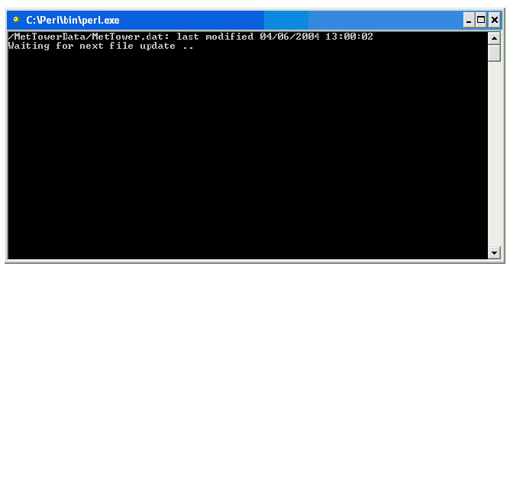

System Maintenance and Calibration

Daily Checks

The data from the tower should be checked each day during daily maintenance rounds. Temperature and relative humidity data from both levels and the CMH should be compared to determine if the data appear reasonable.
Any discrepancies should be noted on the daily rounds forms. The wind speed and direction data should be checked to determine if the values appear reasonable to the current conditions. The barometric and present weather data should be checked to determine if what is being reported also appear reasonable. For example, if the present weather sensor is reporting 100m visibility and heavy snow when it is clear and sunny out, this indicates a problem with the present weather sensor and should be noted. The present weather sensor also has an alarm value. If everything is working properly the alarm reading should be “0”, if there is a problem the alarm reading will be “1”. Data from the barometer should be between 800 and 1100 hPa. If the barometric data is outside of these values then this should be noted on the daily forms. An RTMC Overview screen has been built which displays 24 hours of data graphed along with text values for the current readings. The graphs will allow checks of the data to be made to determine if problems have occurred during the most recent 24 hours. Long gaps in data, long periods of or many data spikes, and flat line data (no change in values over extended periods) will be apparent and should be noted on the form.

Monthly Checks

Once a month the auto balance dial reading should be taken for the CMH. The auto balance reading is an indication of the contamination on the surface of the mirror. To obtain a reading, open the control box and locate the auto balance dial in the upper right hand corner of the control box. It resembles a typical gym locker dial. The knob has increments of two and numerals in increments of 10 starting at 0 and going through 90. The window has numerals of 1 through 10. To take a reading, use the window value to read the hundreds and the dial to read the tens and ones. For example, if the window has the numeral 0 and the dial is on the third division between 0 and 10, then the reading is 6. If the window has the numeral 1 and the dial is on 60, then the reading is 160. This value should be recorded once a month on the daily forms. When the reading reaches or exceeds 500, the mirror will need to be cleaned and the entire sensor will have to be recalibrated. See Appendix J, or sections 2-3.3 through 2-4.3 of the manual for the procedures to clean and recalibrate the sensor.

Six-Month Checks

Present Weather Sensor

The lenses of the present weather sensor need to be cleaned every six months. Remove any condensed water, ice or snow that may be on the hoods or lenses. Wipe away any dust from the inner and outer surfaces of the hoods. Using a clean, lint-free cloth and isopropyl alcohol, moisten the cloth with alcohol and gently wipe the lenses. Clean the capacitive rain detector every six months using a soft, lint-free cloth moistened with mild detergent. The date and time of cleaning should be entered into the daily rounds forms.

Chilled Mirror Hygrometer

The CMH should be cleaned and recalibrated every six months to ensure proper functioning and that reasonable data is returned from the sensor. See Appendix J or sections 2-3.3 through 2-4.3 of the manual for the procedures to clean and recalibrate the sensor. The date and time of cleaning should be entered into the daily rounds forms.

Annual Checks

Cup Anemometers and Wind Direction Vanes

The bearings in these sensors need to be checked once a year. These checks should not be made when the air temperature is below –17.5°C (0°F) at any level of the tower. The tower will have to be lowered to access the wind speed and direction sensors. Carefully remove the cups from the anemometers or the vane from the wind direction sensors and spin the shafts. They should spin freely. Slowly turn the shafts with ungloved fingers to sense anything irregular such as dirt or a flat spot on a bearing or a rubbing disk. Also inspect the cups and vane for any signs of damage. If any irregularity is observed, replace the respective anemometer or wind direction sensor.

HMP45D Temperature and Relative Humidity Probes

The filters on the probes need to be checked once a year and replaced if dirty. These checks should not be made when the air temperature is below –17.5°C (0°F) at any level of the tower. The tower will have to be lowered to access the sensors. Remove the air intake from the aspirated radiation shield by unscrewing it. Remove the protective cover from the probe and inspect the filter. Replace the filter if it is dirty. Reassemble the probe and aspirator.

PTB201 or PTB220 Digital Barometer

Compare the reading of the digital barometer with the reference digital barometer. Record both readings on the daily forms.

FD12P Present Weather Sensor

Check the visibility calibration once a year using the FDA12 calibration kit. See Appendix G for the procedures to clean and calibrate the present weather sensor.

Two-Year Checks and Replacement

Wind Speed and Direction Sensors

Check the calibration of the current cup anemometers and the frequency measuring portion of the QLI50 Sensor Collectors by using the R. M. Young Model 18810 Anemometer Drive to spin the anemometer shafts for at least one minute at the different rpms. Check the calibration of the current wind vanes and decoding portion of the QLI50 Sensor Collector. Obtain the readings from either the RTMC Overview screen or by directly connecting to the logger and viewing the Input Location data. Remove and replace the anemometer and direction sensors. Check the calibration of the newly replaced sensors. See Appendix I for procedures and forms.

Temperature and Relative Humidity Sensors

Check the calibration of the current temperature and relative humidity probe by comparing it to the reference probe. Ensure that there is proper flow over both the reference and the current probe and that little or no direct solar radiation influences the reading. Replace the probe with one that has a current calibration. Check the calibration of the newly replaced probe before returning to service. See Appendix H for procedures and forms.

APPENDIX A

LOGGERNET SET-UP
NSA LoggerNet SET-UP FOR SMET, SKYRAD, & GNDRAD

- Setup and start PC. Ensure the PC is connected to the network and the loggers and NL-100’s are connected and running.
- Create the following directories on the PC:

  - C:\ARM\bin
  - C:\SendDir\SkyRadData, GndRadData, MetData
  - C:\SkyRadData, GndRadData, MetData
  - C:\SkyRadPgm, GndRadPgm, MetPgm

- Start LoggerNet if it not already running (task bar will be on desk top if it is)
- Click on the Setup icon

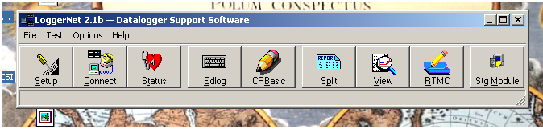

- Once the Setup interface starts click on the Add Root button and choose IPPort.

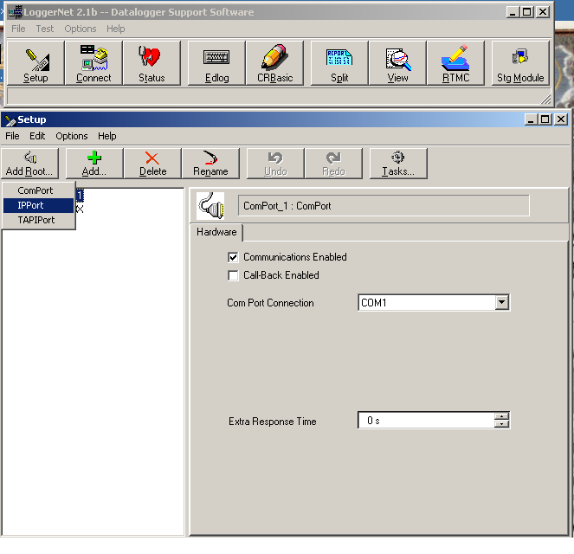

- Once the IPPort has been added, enter the IP address supplied for each logger (SKYRAD, GNDRAD, MET). Ensure the Communications Enabled box is checked. Set Extra Response time to 0 s if not already done. Call-back Enabled should not be checked.

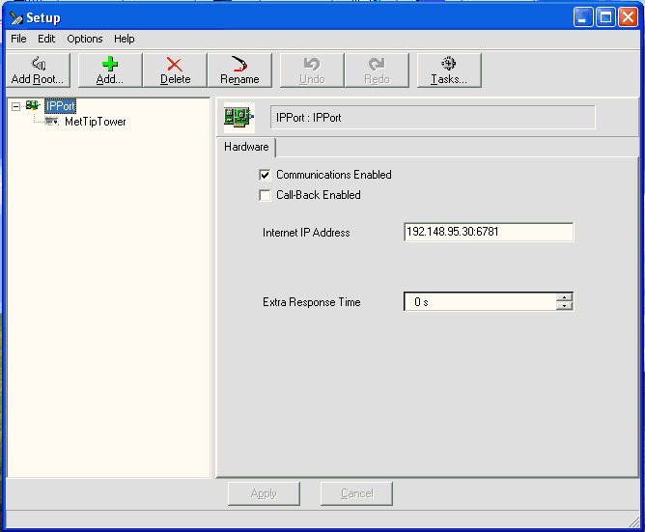

- Once the IPPort has been added you can change the name. Suggestion would be to change the name to IPPort.Met.32. Where .Met is system (Sky, Gnd) and .32 is last digits of the IP address for each respective logger. This is not necessary but may help in identification.
- Click on the Add button to add a datalogger under each IPPort. Choose CR23X. Once you highlight the logger type, click on the Add Now button. You must click on Close afterwards to shut down the Add Device window. Clicking the Add Now button will add multiple loggers if done more than once. If this occurs, highlight the unwanted loggers by clicking on them and then on the Delete button.

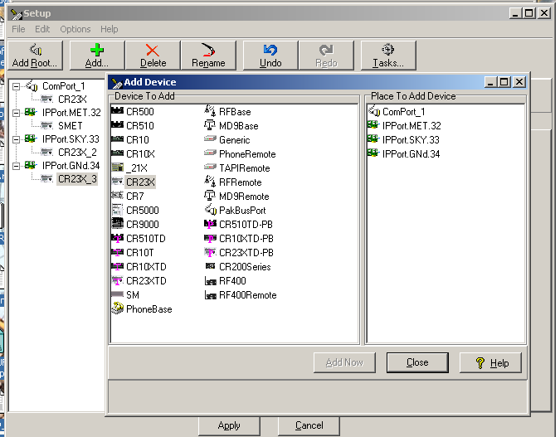

- Once the logger has been added you should rename it either using the Rename button or highlighting and using right mouse button. Suggested names are: MET, SKYRAD, GNDRAD.
- Left click on a logger to access the remaining connection information so that it can be reconfigured.

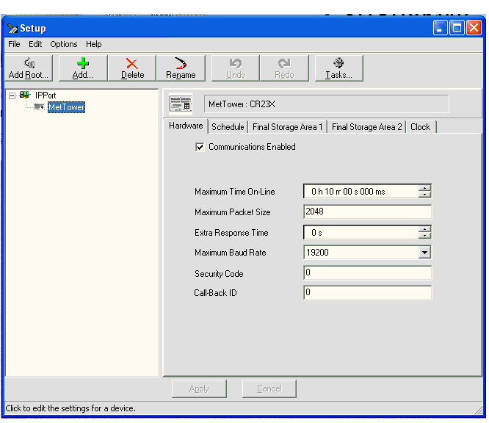

- Ensure the Communications Enabled box is checked and leave all settings under Hardware tab as default.
- Click on the Schedule tab and change the following settings: ensure Scheduled Collection Enabled box is checked. Change Collection Interval to 01m, rest 0’s. Change Primary Retry Interval to all 0’s and Number of Primary Retries to 0. Set Secondary Retry Interval to 05 s and remove the check in Collect Ports and Flags. Leave everything else as defaults.

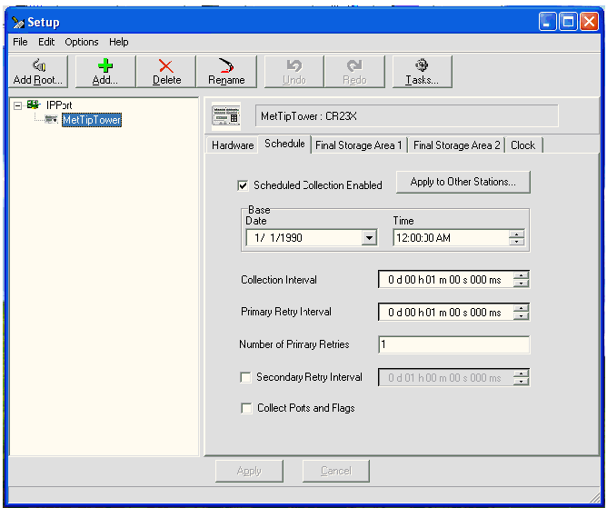

- Click on Final Storage Area 1 tab and make the following changes to the settings: check the Enable for Collections box and change the destination of the data file to the directory created in step 2 (SkyRadData for SKYRAD, GndRadData for GNDRAD, etc) and change the name of the data file to the name of the system you are collecting from (example for skyrad: C:\SkyRadData\SKYRAD.dat). Uncheck the Use Default Name box. Under File Output Option click the Append to End of File radio button. Under Output Format click the ASCII, Comma Separated radio button. Under Collect Mode, click on Data Logged Since Last Call radio button and check the Collect All on First Call box.

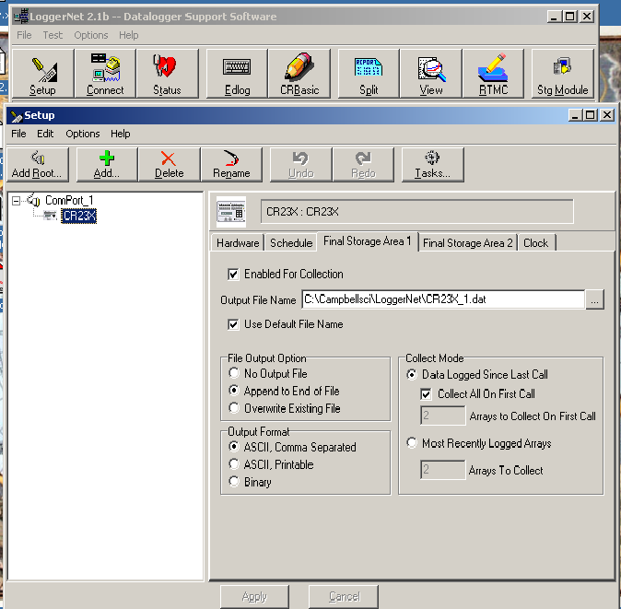

- Click on the Clock tab to make changes to the following settings: Leave Time Zone Offset as 0h 00m. Under Automated Clock Check click the Enabled box. You can leave Initial Date as default, but make sure Initial Time is XX:XX:30 (add five seconds to subsequent systems, i.e. met XX:XX:30, sky XX:XX:35, etc) so that any clock check occurs at 30 sec past the minute with a 5 second separation between clock checks. Set Interval to 01 d, for once per day. Set the Allowed Clock Deviation to 1 sec.

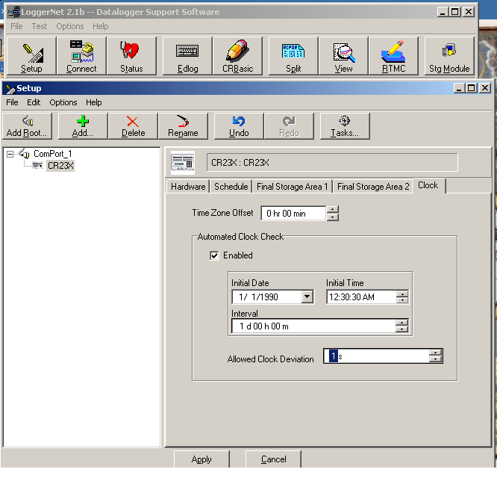

- You will not need to make any changes to the settings in the Final Storage Area 2 tab. Just ensure that the Enabled for Collections box is not checked.
- Once the above steps are complete you should be able to connect to each of the loggers using the Connect button in the main menu.

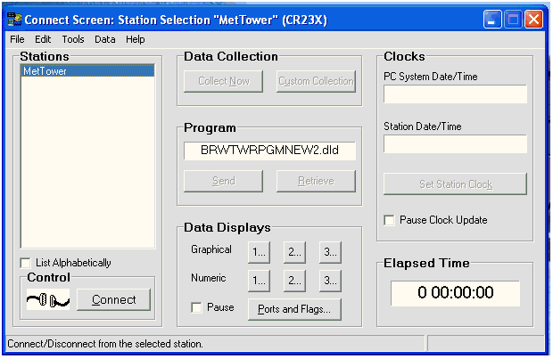

- The loggers you added in the above steps will be listed in the “Stations” menu. Highlight the logger you wish to connect to and click on the Connect button on the bottom. If everything is connected and correct the wires in the “Control” display will connect. To send a program to the logger, click on the Send button under the “Program” portion of the Connect screen. Navigate to the directory where the program is stored (should be C:\SkyRadPgm, GndRadPgm, MetTowerPgm) and select the appropriate program. Once the program has been selected, click on the Send button. A warning banner will be displayed stating that continuing will cause all data to be lost. Continue to send the program by clicking on the Ok button. Once the send is complete and the logger has compiled the program, another message banner will be displayed, click on Ok to finalize the transmission. Once connected and a program is running (assuming sensors connected) you can view the raw data and final stored data by clicking on the numbers in the “Data Displays” section of the Connect screen.
****A NOTE OF WARNING: CONNECTING TO A LOGGER USING THE CONNECT SCREEN CAN DISABLE COMMUNICATIONS TO OTHER LOGGERS ON LOGGERNET. DATA MAY NOT BE COLLECTED WHILE YOU ARE CONNECTED THIS WAY. REGULAR COMMUNICATIONS WILL BE RESTORED WHEN THE CONNECTION IS SEVERED.

APPENDIX B

PERL SCRIPT SET-UP
PERL SCRIPT SET-UP

${DataDir} = The name of the output directory used by LoggerNet
${DataFile} = The name of the output file used by LoggerNet
For example we used the following for the MetTower at Barrow:
${DataDir} = MetData
GndRadData
SkyRadData
${DataFile} = Met.dat
GndRad.dat
SkyRad.dat

1. Create directories:
- C:\ARM\bin
- C:\SendDir\${DataDir}(for All three systems)

2. Copy split_working_cdl.pl script to C:\ARM\bin

3. Install ActivePerl-5.8.0.806-MSWin32-x86.msi
- Choose default options
4. Install susetup.exe (Serv-U FTP Server)
- Choose default options
- Remove any anonymous users and accounts
- Add Domain: ftp.arm.gov
- Create User: sds
- Password: pa55word
- Home Directory: C:\SendDir
(don't worry about subs--inherit subdirectories)
- DirAccess:
Files:
x Read
x Write
x Append
x Delete
Execute
Directories:
x List
x Create
x Remove
Sub-directories:
x Inherit

5. Schedule split_working_cdl.pl script in LoggerNet Tasks:
(three times at same time)
6. Click on Setup button on main LoggerNet task bar.
7. Click on the Task button.

8. Click on Add Scheduled button on lower left hand side of window.
This will be done once for each scheduled split.
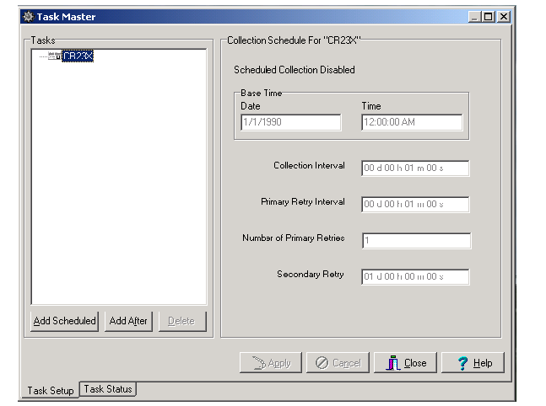

9. Rename the task in the window by right clicking on the highlighted task and rename each as: SplitMetData, SplitGndRadData, SplitSkyRadData

- Change the following in the “Scheduled Event” section
Base Date: any previous date (i.e. 5/7/2004)
Base Time: 12:00:50 AM

Event Interval: 0 d 01 h 00m 00 s

- In the “What Task Does” section do the following for each task.
Check box for Execute File:
File Name: C:\ARM\bin\split_working_cdl.pl
Command Line Options:
-f GndRad.dat –i /GndRadData –o /SendDir/GndRadData
-f SkyRad.dat –i /SkyRadData –o /SendDir/SkyRadData
-f MetTower.dat –i /$MetTowerData –o /SendDir/$MetTowerData
The generic format is:
-f ${DataFile} –i /${DataDir} –o /SendDir/${DataDir}
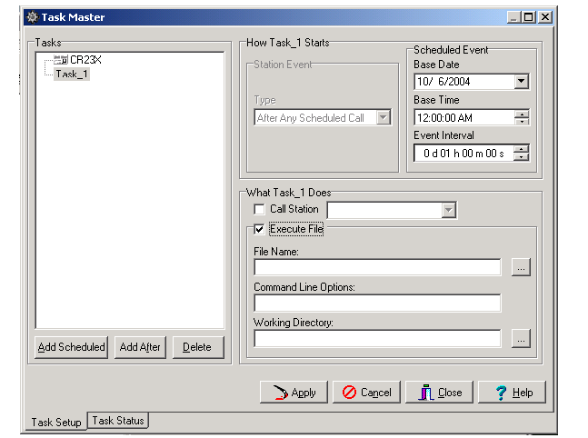

Working Directory:

C:\MetTowerData
C:\SkyRadData
C:\GndRadData
The generic format is:

C:\${DataDir}

When finished, click on the Apply button.

APPENDIX C

NL-100 SET-UP
NL-100 SET-UP

In order to communicate with the NL-100 you need a Null-modem cable and a PC or Laptop with a terminal communication package. It is assumed for the rest of this document that HyperTerminal is used. You will also need 12VDC to power the NL-100.

Connect the null modem cable to the PC and the NL-100. You will need a cable with female connections at both ends. Use gender adaptors if necessary. If this is the first time communicating with the NL-100 after receipt from factory go to step 1b.

1a. Open NL-100 by removing four screws. Connect boot jumper across both terminals.
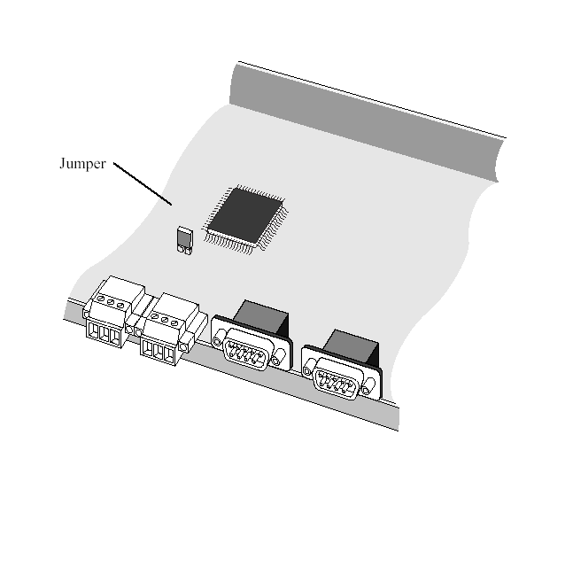
1b. Connect power to NL-100 and connect Null Modem cable.

1c. Open hyperterminal and use following settings:
baud: 115200
databits: 8
parity: none
stop bits: one
flow control: none

2. Strike the Enter button a few times to get the attention of the NL-100 once the following is returned you may continue:

NL100/105 (ver, show, edit, defaults, reset, help, bye):

3. Type E to Edit and make sure the following is set:
Tlink config [dis]
RS485 [dis]
CS I/O [dis]
RS232 Config [TCPServ]
RS232 bps [19K]
RS232 Serial Server Port [6781]

Ethernet 10-baseT [enabled]
10-baseT port IP# [192.148.95.30] **this value is logger IP address
mask [255.255.255.0]**whatever mask is used
default gateway [no]
Pakbus node [678]
Clock neighbor node ID [0]
PakTcp Server config [dis]
PakTcp client config [dis]
Modbus/Tcp gateway config [dis]
Config monitor telnet port [23]
Telnet Session password [nl100]
Serial Server Watchdog [2]

Save

You can progress through the menu by pressing <ENTER>. If you make a mistake after entering a setting, the up arrow can be used to move backwards. If you need help for a particular setting, press the F1 key or the ? key. You can also choose to select <cancel> at the end instead of save if you want to start over.

**If the jumper was used it must be disconnected before returning the NL-100 to use. If this is not done, the NL-100 will always be at the boot prompt and will be inaccessible for remote communications.

APPENDIX D

SDM-SI04 SET-UP
SDM-SI04 SET-UP

There are two ways to set up the SDM-SI04 serial data multiplexer. One is a direct connection between the SDM and a laptop/PC. The other is using the set-up portion of the program in the CR23X datalogger to which the SDM is connected. Using the set-up portion of the program is easier than direct connection to the SDM via a laptop although both methods are discussed.

FIRST TIME USE

1. In order to do the set up a 12V supply, a null modem cable and a Laptop/PC with HyperTerminal will be needed. At Atqasuk, the address of the SDM is left as configured by the manufacturer (default is 0). If this is not the case, the SDM will need to be opened and its jumpers changed so the address is 0. See page 2-1 in the manual to determine the placement of jumpers.

2. Connect the 12V supply to the SDM and connect the null modem cable to port 1 of the SDM and to the required port of the laptop/PC for HyperTerminal. The settings for HyperTerminal are: 9600, 8, 1, no flow control. In order to get the attention of the SDM you will need to depress the “set up” button on the front of the SDM. When the SDM is ready to accept commands it will send the prompt to the communication program (SDMSI04->).

3. Once the prompt is visible, type in the following commands below to load the strings and filters that tell the SDM what to send each sensor and how to filter the returned data from each sensor. The commands must be typed in exactly as shown, capitals, spaces and special characters are extremely important. If you make a mistake the SDM will either prompt you that it does not understand the command or if you make a typo that the SDM accepts you can re-type the information or type “reset” which will put the SDM back to default configuration. If you type “reset” any data already entered will be removed. If you miss any spaces the SDM will not alert you and it will appear that the SDM accepted the command. In reality, it ignored the command. The “^” is not a placeholder or a proxy value for a space. The “^” is part of the ASCII variable set and has meaning.

For the PTB220/201 Barometer type:

strst 2 “SEND^M^J”
fltst 20 “xfz”

For the FD12P Present Weather Sensor type:

strst 3 “^EFD12^M^J”
fltst 30 “t[FD]n4dddn3dddffdz”

For the Model 1088 Chilled Mirror Hygrometer type:

strst 4 “T1^M^J”
fltst 40 “t[T]b1u[/]t[D]b1fz”

For the Vaisala QLI data collector type (there are 10 f’s):

fltst 10 “t[AA]xffffffffffz”

4. Next, you will need to configure the communication parameters for each of the ports. The sensor itself dictates the communication parameters. The following will need to be typed in exactly as shown: (spaces are needed)

portset 1 9 2 0 2 9
portset 2 9 2 0 2 9
portset 3 8 3 0 0 9
portset 4 9 2 0 2 9
exit

5. Once the above is accomplished, the SDM is ready to be installed in the field but it is not prepared to accept data from the sensors. Even though the information is stored in the battery-backed memory, the filters and strings are not associated with any particular port. To associate the filters and strings with a port the SDM will have to be connected to the CR23X datalogger and the set up portion of the program written to associate the filters and strings will need to be run.

6. Connect ports C1, C2 and C3 of the SDM to ports C1, C2 and C3 of the datalogger. Connect the 12V terminal of the SDM to a 12V terminal of the datalogger and the G of the SDM to any G of the datalogger. Once this is done the SDM is ready to accept the set up program.

Reconfigure SDM using main Met Program

1. The set-up program is located on the CR23X and is a part of the current program. To connect to the MET CR23X datalogger, go to the main LoggerNet menu bar. Click on the Connect button. Choose the MET logger from the menu on the left hand side under “Stations” and click on the connect button on the lower left hand side under “Control”. Under “Data Displays” click on one of the “numeric” buttons and then click on “Add” and select “InLocs” from left hand side and choose the following:

Qfltrcode (QLI filter code)
Bfltrcode (Barometer filter code)
Bstrcode (Barometer string code)
Pfltrcode (PWS filter code)
Pstrcode (PWS string code)
Cfltrcode (CMH filter code)
Cstrcode (CMH filter code)

These will show the value of the return code, which will indicate whether there was a successful load. The number 23 will be returned if load was successful. If any other number is returned, copy it down and contact the mentor. The set-up portion of the program will only run if Flag one is set high. On the “Connect” screen under “Data Displays” click on the ports and flags button and click on the radio button to the left of Flag 1. The button will turn green indicating the program is running. It will turn dark again when it is finished.

2. When the set-up program is finished, ensure that the sensor serial cables are connected to the proper ports (BARO – 1, QLI – 2, CMH – 3, PWS – 4).

The actual program contains all the filters, command strings, and port settings for the SDM. Any changes to the above will require changes to the main met program. New sensors, new methods, etc will have to be tracked to insure that these changes are incorporated into the SDM set-up portion of the main program.

******BE AWARE WHENEVER FLAG 1 IS SET HIGH NO DATA
******WILL BE COLLECTED BY THE SYSTEM FOR ABOUT 40 SECONDS.

APPENDIX E

BAROMETER SET-UP
VAISALA PTB-201 SET-UP
FOR ALL CAMPBELL LOGGERS

The Barometers are serial devices and to connect to them you will need:

A computer
A 9-pin straight through serial cable
A 12-volt supply for power to the Barometer (logger)
A serial communication program such as HyperTerminal
A special built connector so 12V and ground can remain on the logger
and TX/RX/GND can be connected to the communications port of
laptop.

- Apply Power to the Barometer and start HyperTerminal. If this is the first time setting up communications to the Barometer to change settings, the following HyperTerminal settings should be used:

  - Baud Rate: 1200
  - Data Bits: 7
  - Parity: Even
  - Stop Bits: 1
  - Flow control: None

If system already in use, the following settings should be used:
SGP/TWP NSA
  - Baud Rate: 1200 1200
  - Data Bits: 8 7
  - Parity: None Even
  - Stop Bits: 1 1
  - Flow control: None None

- The following commands will change the settings in the Barometer to match what the Campbell Dataloggers need: DO NOT TYPE QUOTATIONS

  - Type “OPEN”
  - Type “ECHO ON”

  - Type “FORM <CR>”
The unit will return the following:
“\PPPP.PP\ \uuuu\\r\n”
?
Or “\PPPP.P\ \uuuu\\r\n
?
The cursor will be after the question mark
Type “\PPPP.P\ \uuuu\\r\n<CR>”
There is a space between the 2nd and 3rd backslash. You MUST type the format after the question mark regardless of the current form. Typing FORM <CR> puts barometer into the “change format mode”
  - Type “UNIT hPa” (probably not needed—but good to check)
  - Type “SERI 1200 N 8 1”
  - Type “ECHO OFF”
  - Type “?” and make sure the following are all the same:

Software version PTB 200 / 2.03

Baud Parity Data Stop 1200 N 8 1
Output format \PPPP.P\\uuuu\\r\n
Pressure unit hPa
Temperature unit 'C
Sending mode STOP
Address 0
Sleep mode OFF
Measurement time 64 x 25 milliseconds
Filter OFF / FAST
Output interval 0 s
Calibration day code 92261
Offset drift comp. ON
Offset drift correction -0.056
Multipoint correction ON

  - If any of the 2nd – 11th settings are not the same as above, see manual to set as above. The last four settings may differ between barometers.
  - Type “RESET” to save all settings.
  - Type “CLOSE”.
VAISALA PTB-220 SET-UP
FOR ALL CAMPBELL LOGGERS

The Barometers are serial devices and to connect to them you will need:
A computer
A 9-pin straight through serial cable
A 12-volt supply for power to the Barometer (logger)
A serial communication program such as HyperTerminal
A special built connector so 12V and ground can remain on the logger
and TX/RX/GND can be connected to the communications port of
laptop.

- Apply Power to the Barometer and start HyperTerminal. If this is the first time setting up communications to the Barometer to change settings, the following HyperTerminal settings should be used:

  - Baud Rate: 9600
  - Data Bits: 7
  - Parity: Even
  - Stop Bits: 1
  - Flow control: None

If system already in use, the following settings should be used:
SGP/TWP NSA
  - Baud Rate: 1200 1200
  - Data Bits: 8 7
  - Parity: None Even
  - Stop Bits: 1 1
  - Flow control: None None

- The following commands will change the settings in the Barometer to match what the Campbell Dataloggers need: DO NOT TYPE QUOTATIONS

  - Type “OPEN”
  - Type “ECHO ON”

  - Type “FORM <CR>”
The unit will return the following:
4.2 P “ “ UUUU #r #n
?
Or 4.1 P “ “ UUUU #r #n
?
The cursor will be after the question mark
Type “4.1 P “ “ UUUU #r #n<CR>”
There is a space between the 2nd and 3rd quotations (must type these). You MUST type the format after the question mark regardless of the current form. Typing FORM <CR> puts barometer into the “change format mode”
  - Type “UNIT hPa” (probably not needed—but good to check)
  - Type “SERI 1200 N 8 1”
  - Type “ECHO OFF”
  - Type “?” and make sure the following are all the same:

Software version PTB 220 / 3.05
Serial XXXXXXXXX
Configuration 1
Linear adjustments OFF
Mulitpoint adjustments ON
Calibration Date XXXX-XX-XX
Baud Parity Data Stop 1200 N 8 1
Echo OFF
Sending Mode STOP
Measurement Mode NORMAL
Pulse Mode OFF SLOW LOW 0.0
Address 0
Output Interval 0
Output format 4.1 P “ “ UUUU #r #n
Error Output Format
SCOM Format
Pressure unit hPa
Temperature unit 'C
Averaging Time 0.5s

  - If any of the 7th – 15th settings are not the same as above, see manual to set as above. The Software Version, Serial and Cal Date settings may/should differ between barometers.
  - Type “RESET” to save all settings.
  - Type “CLOSE”.

APPENDIX F

QLI SET-UP AND PROGRAM
QLI SET-UP

- Run 12V power to pin 33 and Common Ground to Pin 34. Do not apply power to the QLI at this time.
- Connect the RS-232 9 pin cable to the QLI. The cables came with the
QLI. Blue – 60, Red – 61, Ylo – 62
- Choose the module and place into the QLI—it will stay in the logger.
“PCB0012 Rev. C Loy 1 RS232 + RS485 Send”
Unless the module is already in place.
- Start HyperTerminal and choose the QLIBASE.TRM hyper-terminal program. If this program is unavailable, use HyperTerminal or some other program with the following settings: 1200 baud, 7 data bits, even parity, and one stop bit, if QLI is factory configured. There may be a different baud rate for Atqasuk QLI’s. A few have been configured for 9600.
- Plug 9 pin cable into the computer port used by the communication program.
- Apply power to the QLI—hit enter 2 or 3 times during the QLI start up to get the same baud rate on the QLI.
- Type BAUD 1200 (instructions on pg 22 & 23 of manual).
- You can check operations by typing in commands on pg 22 & 23 of manual.
- Close out the QLIBASE terminal program or other communication program.
- Open the TERMQLI program (comes with the manual). If you are using a Windows OS after NT4.0 you will have to use the arrows and ALT-“letter” on the keyboard to navigate, as the mouse will not work. The program is a DOS program
- Choose from menu QLI – load (ALT-L).
- Choose the program (ATQASUK.QLI) to load to the QLI. This may take several attempts and sometimes the program loads even when you get an error message.
- Once the program is loaded close TERMQLI.
- Open the QLIBASE hyper-terminal or other communication program again. Follow steps 6 above to get same baud rate. If the baud rate of the QLI will be different than 1200 type BAUD XXXX. You may need to disconnect and change the settings of the communication program to re-establish a link with the QLI.
- Type ECHO OFF.
- Type CLOSE.
- Steps 15 & 16 must be done or QLI will not respond.
- Since the output is set to automatic 1 per second, the QLI output should begin to be printed on the communication screen.

QLI PROGRAM

The following is the program used by the QLI to collect data from the wind speed and direction sensors and the HMP-45D temperature & relative humidity probe. The following should be copied to a text editor such as Notepad and the extension of .txt should be replaced with .QLI. Alternatively, the Termqli program that comes with the manual can be used to create the program below. See the manual for an explanation of all commands and sequences.

; Program for QLI sequence A
PULL DOWN
SEQ A\
0PT100(X1)\
2+VE(PON,X2,S1 100,FRM 51H)\
TDEW\
1PT100(X1)\
3+VE(PON,X2,S1 100,FRM 51H)\
TDEW\
F1(S1 0.1,DLY 5,UN 19,FRM 51H)\
GRAY(S1 5.625)\
UIN\
TIN\
END
REP A 1 S
AMES 2
SAVE
; End of program

APPENDIX G

PRESENT WEATHER CALIBRATION

AND SET-UP
CALIBRATION PROCEDURES FOR THE
FD12P PRESENT WEATHER SENSOR

- Remove the current serial line from the Control Unit (note the colors of the wires and to what terminal they are connected) and connect another serial cable to the terminals.
- Start HyperTerminal.
- Set CAPS LOCK ON (PWS commands are all capitals)
- In HyperTerminal go to FILE>Properties
  - Under “CONNECT TO” tab Connect using: COM 1
  - Under “CONFIGURE” button:
    - Bits = 1200
    - Data Bits = 7
    - Parity = even
    - Stop bits = 1
    - Flow Control = none
  - Under “SETTINGS” tab
    - Terminal keys: on
    - Emulation: ANSI
    - Back Scroll Buffer Lines: 500
    - Terminal Settings: underline and blink
  - Under “ASCII SETUP” button
    - Under Sending:
      - Echo Typed Characters Locally: no
      - Line Delay: 0
      - Character Delay: 0
    - Under Receiving:
      - Append Line Feeds: yes
      - Wrap Lines: yes
- Connect (using file>connect, call>call, or phone icon) to the present weather sensor. Name the file PWSCALxx/xx/xx where the x’s stand for month, date, and year.
- Clean the PWS transmitter windows with the spray and soft cloths in the Visibility Calibrator Set FDA 12. Allow the windows to dry for about 5 minutes.
- Hit return a few times to get a prompt.
- Type OPEN ^C (^ indicates control key) then hit ENTER
- Type CLEAN then hit ENTER
- Record the Transmitter and Receiver settings
- Insert the Black Blocking plate tightly into the right shield of the sensor (small disk toward the inside of shield, plate handle hanging down)
- Type CHEC then hit ENTER
- Wait until the reading stabilizes around a small range of values (about 5 minutes or so, usually)
- Record the value. The actual value should be less than +/- 0.1 Hz.
- Hit ESC key to end the check.
- Install the opaque calibration plates. See installation instructions in the calibration case. The mounting clamp is on the sensor horizontal tube. The plates are labeled “Right” and “Left”. Be careful with them, they are glass. Do not get fingerprints on them. Clean them with the cloth and spray if necessary.
- Type CHEC then hit ENTER
- Wait for readings to stabilize around a small range of values (usually about 5 minutes or so)
- Record the value (should be +/- 39 Hz of the calibration plate value 1287 Hz).
- If values do not fall in this range, move the mounting clamp up or down slightly. This step may take some time as the mounting clamp allows for quite a bit of play.
- Hit ESC to end the check.
- Type CAL 1287 then hit ENTER.
- Type CHEC then hit ENTER.
- Write down the “scaled frequency average”
- Hit ESC to end check.
- Type TCAL then hit ENTER.
- Record the TS (third value)
- Type CLOSE then hit ENTER.
- Disconnect and close out HyperTerminal, you should save the entire session and email the .TRM session to the mentor for recording.
- Remove serial connector from the back of the PC and the Control Unit terminals and reconnect the serial cable that goes to the SDM_SI04 located in the Met Logger Enclosure.
- Wait a few minutes to see if the PWS data shows up on the Met program.
- If the data does not show up after a minimum of 10 minutes, it may be necessary to clean the lenses again. Follow steps 1 through 9 again. Although you may use the original saved HyperTerminal session.
- Type CLOSE then hit ENTER.
- Follow steps 29 – 31 again to reconnect PWS to collector system.
- If data does not show up after a few minutes, contact the mentor.

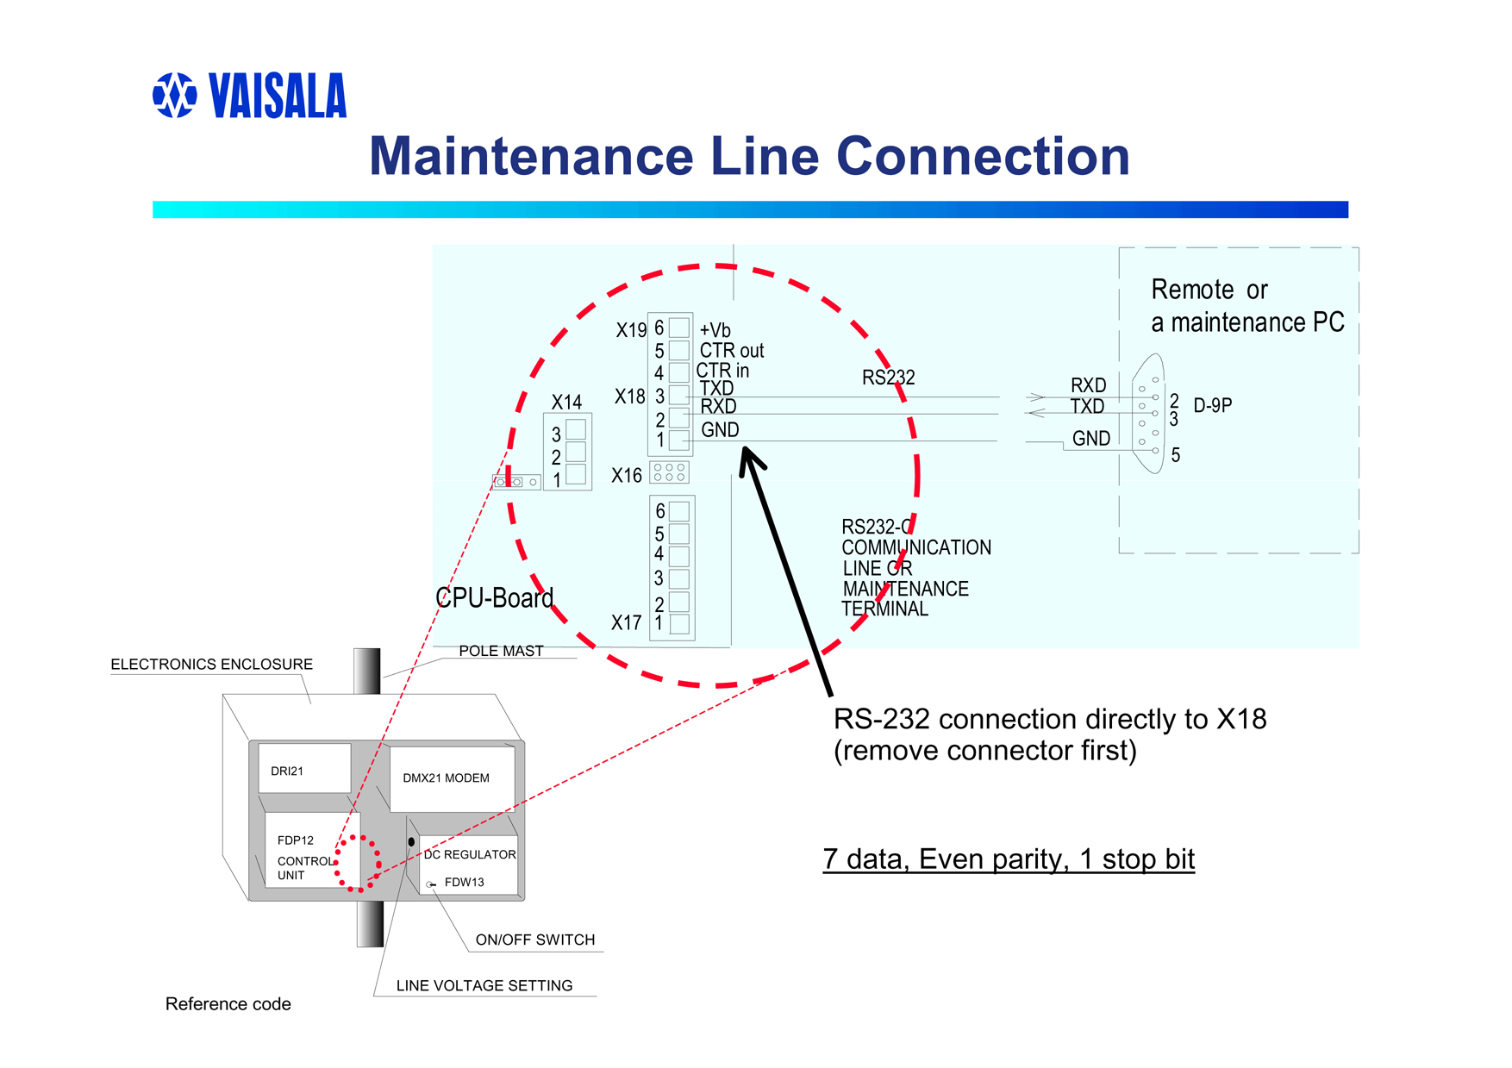

PRESENT WEATHER CHECK SHEET

Tested by:_________________________ Date:___________________

Time began:_______________ Time ended:___________________

General Weather Conditions:

Clean
Transmitter:____________

Receiver:_______________

Block Plate Check

Scaled Frequency Average:__________________

Calibration Plate Check

Scaled Frequency Average:__________________

Is Calibration required? Yes/No

If so, CAL final value:______________________

TCAL Check

TS value (last value on right):_________________

CMH Temperature:_________________________

2m T/RH Temperature:______________________

Is reported one-minute visibility value reasonable? Yes/No

PRESENT WEATHER SENSOR
SET-UP

- Remove the current serial line from the Control Unit (note the colors of the wires and to what terminal they are connected) and connect another serial cable to the terminals.
2. Start HyperTerminal.
- Set CAPS LOCK ON (PWS commands are all capitals)
- In HyperTerminal go to FILE>Properties
  - Under “CONNECT TO” tab Connect using: COM 1
  - Under “CONFIGURE” button:
    - Bits = 1200 (unless first time then 300)
    - Data Bits = 7
    - Parity = even
    - Stop bits = 1
    - Flow Control = none
  - Under “SETTINGS” tab
    - Terminal keys: on
    - Emulation: ANSI
    - Back Scroll Buffer Lines: 500
    - Terminal Settings: underline and blink
  - Under “ASCII SETUP” button
    - Under Sending:
      - Echo Typed Characters Locally: no
      - Line Delay: 0
      - Character Delay: 0
    - Under Receiving:
      - Append Line Feeds: yes
      - Wrap Lines: yes
- Connect (using file>connect, call>call, or phone icon) to the present weather sensor. Name the file PWSCALxx/xx/xx where the x’s stand for month, date, and year.
- Type OPEN^C then hit ENTER.
- Type AMES 2 then hit ENTER.
- Type BAUD 1200 then hit ENTER. Only do this step if baud is not 1200.
- Type CLOSE then hit ENTER.
- Before typing CLOSE you can enter in other maintenance commands to check operation of the PWS:
  - STA – returns result of built-in test.
  - PAR – returns current system parameters.

***MUST TYPE CLOSE AT END OR PWS WILL NOT RESPOND TO REGULAR COMMANDS FOR DATA.

APPENDIX H

TEMPERATURE AND RELATIVE

HUMIDITY CHECKS

Temperature and Relative Humidity
Check Procedures

This check requires two people. One person outside taking readings using the VTP6 Field Calibration probe and one person inside collecting readings from the installed sensors using the RTMC programs or by directly connecting to the logger and viewing the raw input data. Two-way radios will need to be used to communicate information.
- Lower tower to access the T/RH probes at both the 2m and 5m levels.
- Place the VTP6 Field Calibration probe outside in the ambient air and turn it on. Do not place in direct sunlight; try to find a shaded area for it to equilibrate to ambient temperatures.
- Rotate the aspirator units so the intake points toward the ground, this will prevent any solar influence to the probe.
- Once the VTP6 has equilibrated (this may take some time), place the probe into the opening of the aspirator intake as close to the T/RH probe as possible without allowing any contact. View the temperature and RH on the VTP6 readout. When values become stable, take the reading and transmit the data to the person inside for comparison and recording.
- Unscrew the intake tube to gain access to the sensor. The measurement head of the HMP-45D’s is removable so that rewiring is not necessary. Grasp the sensor body and pull downwards. Do not grasp by the filter as it can pull off and damage the sensors. Once the sensor is removed, make note of the S/N number and transmit it to the person inside.
- If not already done, make note of and transmit the S/N of the recently calibrated probe to be installed to the person inside.
- Place the new sensor into the main body of the sensor. Replace the intake tube by screwing it back into the aspirator unit. Wait about 5 minutes or so for the new sensor to equilibrate to being in the aspirator unit. Do not allow the VTP6 to sit in the sunlight during this time.
- Once the new sensor has equilibrated, repeat step 4 with the new sensor installed.
- If readings do not agree, allow a longer period of time for the new sensor to equilibrate and ensure the VTP6 is kept in a shaded area during this additional time.
- If readings still do not agree, replace the sensor with another recently calibrated probe. If none are available, leave the new probe installed and contact the mentor.
- Repeat all steps above for both the 2m and 5m levels.
- The VTP6 requires a 9-volt battery; if problems are occurring with the VTP6 try replacing the battery, if problems continue, contact the mentor.
NSA
TEMPERATURE SENSOR VERIFICATION

Tested by: Date:________________

Time began_________________ Time ended___________________

LOCATION:__________________ LEVEL: _____M

TEMPERATURE

VTP6 OLD HMP-45D

_________ ______________

NEW HMP-45D

_________ ______________

Do the readings from the HMP-45D’s agree within +/- .5 deg C of the VTP6?

Yes / No

Comments:_____________________________________

RELATIVE HUMIDITY

VTP6 OLD HMP-45D

__________ ______________

NEW HMP-45D

__________ ______________

Do the readings from the HMP-45D’s agree within +/- 3% of the VTP6?

Yes / No

Comments:____________________________________

S/N old HMP-45D:_________________________

S/N new HMP-45D:________________________

APPENDIX I

WIND SPEED AND DIRECTION

CHECKS
WIND SPEED AND DIRECTION
CHECKS AND PROCEDURES

This check requires two people. One person outside taking readings using the RM YOUNG RPM Generator and one person inside collecting readings from the installed sensors using the RTMC programs or by directly connecting to the logger and viewing the raw input data. Two-way radios will need to be used to communicate information.

- Lower the tower to access the wind speed and direction sensors.
- Grasp the wind speed sensor shaft and cups to determine if the heater is working (only works when ambient temperatures are below 32 F). Grasp the shaft of the wind direction sensor to determine if the heater is working.
- Remove the cups from the anemometer and install the RPM Generator. Start the generator and using the buttons with arrows, change the RPM’s to each of the required settings. Let the RPM generator stabilize at each setting and allow it to run at least 2-minutes before taking the reading inside.
- Once all RPM readings have been taken, remove the wind speed sensor and install the new one. Follow step 3 above to take RPM readings for the new sensor. Transmit the S/N of both the old and new sensor if not already done.
- Re-install the cups and if temperatures are low enough, grasp the shaft and cups to determine if the heater is working for the newly installed sensors.
- If it is too windy to firmly hold the wind vane steady, remove it before checking the direction values.
- Hold the vane or the shaft steady along the four quadrants (N, S, E, W) and wait at least 2-minutes before taking a reading for each quadrant.
- Remove the wind direction sensor and install the new one. Follow step 7 above to take the readings for the new sensor. Transmit the serial numbers of both the old and new sensors if not already done.
- Re-install the wind vane and if the temperatures are low enough grasp the shaft to determine if the heater is working.
- Once all sensors have been replaced and verified to be working correctly, the tower may be raised back into the vertical position.

WIND SENSOR VERIFICATION

Tested by: Date:

Time began_____________________ Time ended____________________

LOCATION_____________ LEVEL______M WIND SPEED CHECKS

S/N Old Sensor:____________________ S/N New Sensor_________________

RPM Calculated speed m/s Measured speed
Old sensor New sensor

200 4.67 – 4.81 m/s _________ __________

300 7.00 – 7.10 m/s _________ __________

400 9.33 – 9.38 m/s _________ __________

500 11.67 +/- 0.2 m/s _________ __________

Are values acceptable for new sensor: Yes / No

______M WIND DIRECTION CHECKS (accuracy +/- 5 deg, resolution 1.0 deg)

Quadrant Measured Value
Old sensor New Sensor S/N Old Sensor

_______ _________ _________ ______________________

_______ _________ _________ S/N New Sensor

_______ _________ _________ ______________________

_______ _________ _________

Are values acceptable for new sensor: Yes / No

APPENDIX J

CHILLED MIRROR CLEANING & CALIBRATION

PROCEDURES
Chilled Mirror Cleaning & Calibration

It is best to do the recalibration and cleaning in an indoor environment. Stable temperatures and dew points are needed. If the unit is outdoors or in an environment where temperature and dew point is fluctuating during the recalibration, the settling time of the unit will take much longer.

Items needed: Fluke meter able to read 0 – 5 V DC, distilled water, lacquer thinner, isopropyl alcohol, cotton swabs.

- Remove CMH unit from the tower and take inside the GW or back to the duplex.
- Leave power disconnected from unit at this time.
- Turn Auto balance dial to 000 so that 0 is read in the “window” and 0 is set to the mark below the window.
- Remove mirror assembly from the sensor housing assembly (white mushroom).
  - Remove retaining screw from side of housing assembly.
  - Grab sensor (from the bottom) by the handle and pull assembly out, you may want to disconnect the sensor data cable. The unit connects through two banana connectors and slides in and out of assembly only one way.

- Once unit is removed, you can begin the cleaning of the mirror. Begin by taking a clean cotton swab and distilled water, thoroughly wet mirror surface using a moistened swab. Once mirror is wet, wash with a gentle circular motion.
- Wipe the surface with a clean dry swab until dry and all loosened material is removed.
- Repeat steps 4 and 5 until the cleaning has no further effect, i.e. dry swab is clean after drying sequence.
- Repeat steps 4 & 5 using lacquer thinner.
- Continue lacquer thinner cleaning until it has no further effect.
- Repeat steps 4 & 5 using Isopropyl Alcohol.
- Continue alcohol cleaning until it has no further effect.
- NEVER use soap or any other detergent to wash mirror.
- Re-install mirror assembly into the sensor housing assembly. Ensure the banana connectors line up before seating mirror assembly. Tighten retaining screw and ensure the grounding cable is connected between the assembly cap and retaining screw.
- Reconnect the sensor data cable to the main housing unit.
- Apply AC power to the unit.

- Turn the Mode Selector Switch to HEAT, and leave on for one-minute. This will ensure a dry mirror after following the cleaning steps above. Turn mode Selector Switch to OPR position after one-minute time period is up.
- Remove AC power.
- Connect a digital voltmeter set to read 0 – 5 V DC to the transmit logic board. Connect the positive lead to the left side of R3 (junction of R8, R3, and C2) on the transmit logic board and the negative lead to ground.
- Reapply AC power.
- THE FOLLOWING STEPS MUST BE DONE WITH A COMPLETELY DRY MIRROR. TO INSURE A DRY MIRROR CHECK THAT THE DEW POINT IS ABOVE THE AMBIENT AIR TEMPERATURE BY TOGGLING THE MONITOR SELECTOR SWITCH BETWEEN Ta and Td AND PUSHING THE MONITOR DISPLAY SWITCH TO READ THE VALUES. NEED TO KEEP Td ABOVE Td. THE FOLLOWING ADJUSTMENTS MUST NOT BE MADE WHILE HEATING THE MIRROR. YOU MUST MONITOR THE Td, AND HEAT AS NECESARRY. MAKE MEASUREMENTS AND ADJUSTMENTS IN BETWEEN HEATING CYCLES. SELECTOR SWITCH SHOULD BE IN OPR POSITION WHEN MAKING ADJUSTMENTS
- Turn the Sd gain adjustment (R21) clockwise until the Sd LED (CR5) just goes on. This is the threshold level. The voltmeter should read approximately 4.9 Volts.
- Adjust the Si gain adjustment (R22) Clockwise until the Si LED (CR9) goes on then let system stabilize then turn the Si gain adjustment Counterclockwise until the Si LED (CR9) just goes off.
- Turn the MODE SELECTOR switch to 0, check the Ta and Td readings by depressing the display switch for both. If necessary, adjust the TA0 and TD0 trimpots to achieve 32.0 with a +/- 0.1 accuracy.
- Turn the MODE SELECTOR switch to 50, check the Ta and Td readings by depressing the display switch for both. If necessary, adjust the TA+ and TD+ trimpots to achieve 22.0 with a +/- 0.1 accuracy.
- Adjust the FAN FAIL trimpot counterclockwise until the FAN FAIL LED comes on. Turn the trimpot slowly clockwise until the LED just goes off, then one full turn clockwise. Verify operation of the FAN FAIL LED by blocking the aspirator intake. Within 30 seconds the light should come on, and after removal of blockage the LED should extinguish within 30 seconds.

APPENDIX K

WIRING DIAGRAMS
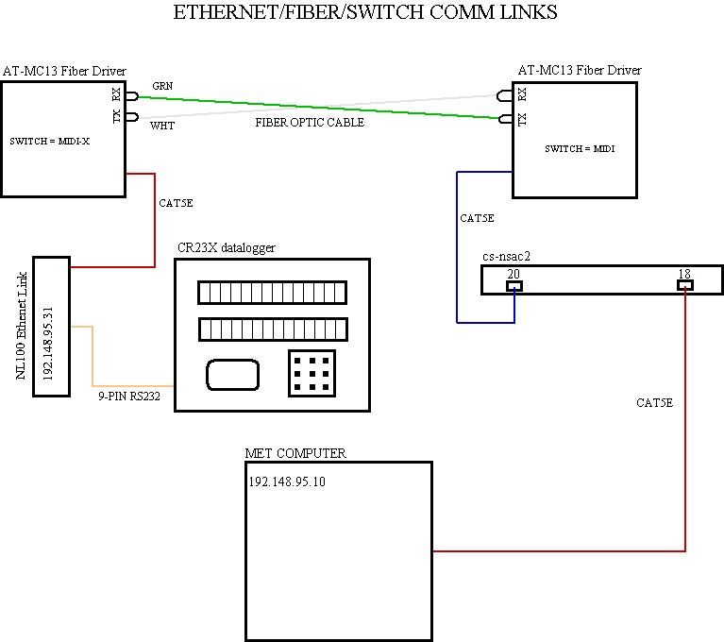
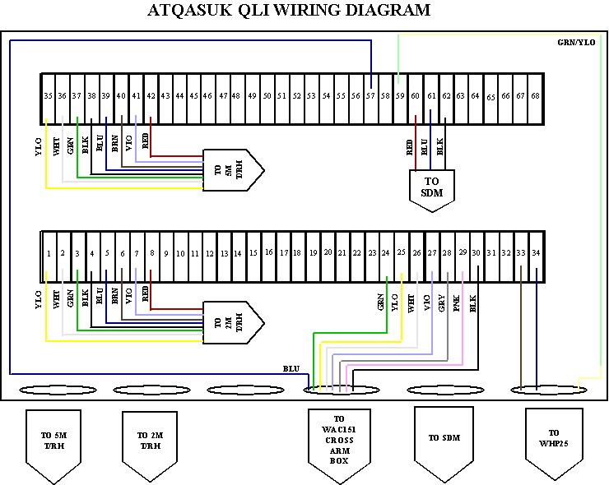

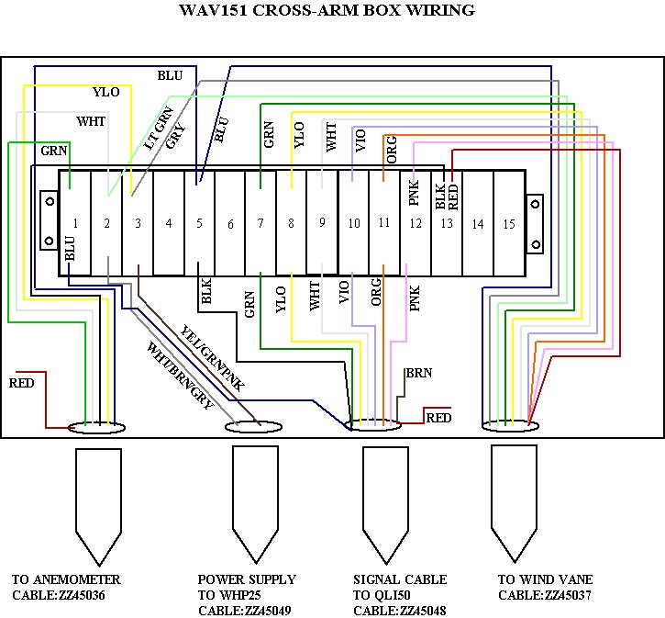

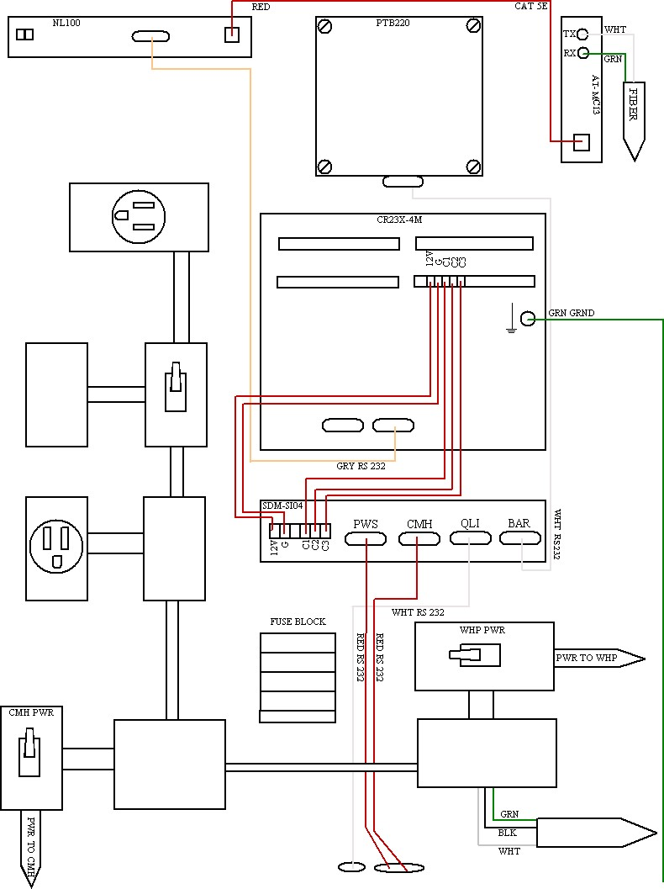

APPENDIX L

DATALOGGER PROGRAM

CR23X DATALOGGER PROGRAM

{CR23X}
;
;Removed Ice point correction from vapor pressure 02.12.2004

;Removed the CS algorithms from all CMH Vp and Satvp calcs and
;used a different calculation and ice point correction 02.24.2004

;Move CMH read to after PWS also added a subroutine to re-poll CMH
;if CMHFDP is < -100 (bad read). Deleted subroutine 7/17/2004.
;Moved Barometer to port 1, QLI to port 2, PWS to port 4 and CMH to port 3
;of the SDM.
;Changed SDM read for Barometer, CMH, and PWS to 5 sec before the minute
;on 07/14/2004.
;Put in disable intermediate processing on all bad reads from QLI
;data (wind, T/RH, and calculated data) on 07/17/2004.
;
;Instituted counters to determine the number of samples used when
;intermediate processing is disabled.
;
;pgm changed 07/17/2004--
;installed--07/17/2004

*Table 1 Program
01:1.0 Execution Interval (seconds)

;Read values from QLI. Temp, rh, dp from 5m level, Temp, rh
;dp from 2m level, Wind speed and direction from sensors at 10m
;QLI voltage and reference temperature. Data read from SDM-SIO4
;address 0 port 1.

1: SDM-SIO4 (P113)
1: 1 Reps
2: 0 Address
3: 1 Send/Receive Port 1
4: 4 Command
5: 0000 1st Parameters
6: 0000 2nd Parameters
7: 10 Values per Rep
8: 1 Loc [ Tupper ]
9: 1.0 Mult
10: 0.0 Offset
;Send a flush the buffers command to the SDM-SIO4 address 0 port 1.

2: SDM-SIO4 (P113)
1: 1 Reps
2: 0 Address
3: 1 Send/Receive Port 1
4: 9 Command
5: 0000 1st Parameters
6: 0000 2nd Parameters
7: 0000 Values per Rep
8: 11 Loc [ Scratch ]
9: 1.0 Mult
10: 0.0 Offset

;Calculate VP from 5m temp and 2m temp and correct for over ice if
;temps below 0 deg C. Also convert from hPa to kPa.

3: If (X<=>F) (P89)
1: 3 X Loc [ DPupper ]
2: 4 <
3: 0 F
4: 30 Then Do

VapPresUp = (6.1359*(EXP((22.452*DPupper)/(272.55+DPupper))))*0.1

4: Else (P94)

VapPresUp = (6.1365*(EXP((17.502*DPupper)/(240.97+DPupper))))*0.1

5: End (P95)

6: If (X<=>F) (P89)
1: 6 X Loc [ DPlower ]
2: 4 <
3: 0 F
4: 30 Then Do

VapPresLo = (6.1359*(EXP((22.452*DPlower)/(272.55+DPlower))))*0.1

7: Else (P94)

VapPresLo = (6.1365*(EXP((17.502*DPlower)/(240.97+DPlower))))*0.1

8: End (P95)
;Set output flag high at each 1 minute interval

9: If time is (P92)
1: 0 Minutes (Seconds --) into a
2: 1 Interval (same units as above)
3: 10 Set Output Flag High (Flag 0)

10: Set Active Storage Area (P80)^18968
1: 1 Final Storage Area 1
2: 1 Array ID

11: Real Time (P77)^15791
1: 1220 Year,Day,Hour/Minute (midnight = 2400)

;Calculate wind vector information.

12: Wind Vector (P69)^3276
1: 1 Reps
2: 0000 Samples per Sub-Interval
3: 02 S, U, theta(u), sigma(theta(u)) with polar sensor
4: 7 Wind Speed/East Loc [ WinSpeed ]
5: 8 Wind Direction/North Loc [ WinDir ]

;Calculate 1-min averages of the temp, rh, and dp data at 5m and 2m.
;Disable intermediate processing if data from SDM is incorrect.

13: If (X<=>F) (P89)
1: 1 X Loc [ Tupper ]
2: 4 <
3: -100 F
4: 19 Set Intermed. Proc. Disable Flag High (Flag 9)

14: If Flag/Port (P91)
1: 19 Do if Flag 9 is High
2: 30 Then Do

15: Z=X+F (P34)
1: 49 X Loc [ QLIcount ]
2: -1 F
3: 49 Z Loc [ QLIcount ]

16: End (P95)

17: Average (P71)^6312
1: 6 Reps
2: 1 Loc [ Tupper ]

18: Average (P71)^25303
1: 2 Reps
2: 16 Loc [ VapPresUp ]

19: If Flag/Port (P91)
1: 19 Do if Flag 9 is High
2: 29 Set Intermed. Proc. Disable Flag Low (Flag 9)

;Capture data from barometer, cmh, and pws at 1 minute interval.

20: If time is (P92)
1: 55 -- Minutes (Seconds --) into a
2: 60 Interval (same units as above)
3: 30 Then Do

;Tell SDM to poll Barometer using poll string: strst 2 "SEND^M^J"
;and use filter: fltst 20 "xfz" to capture returned info.
;SDM is address 0 port 2.

21: SDM-SIO4 (P113)
1: 1 Reps
2: 0 Address
3: 2 Send/Receive Port 2
4: 2304 Command
5: 8002 1st Parameters
6: 9020 2nd Parameters
7: 1 Values per Rep
8: 11 Loc [ Scratch ]
9: 1.0 Mult
10: 0.0 Offset

22: Delay w/Opt Excitation (P22)
1: 1 Ex Channel
2: 0 Delay W/Ex (0.01 sec units)
3: 10 Delay After Ex (0.01 sec units)
4: 0000 mV Excitation

;Tell SDM to poll PWS using poll string: strst 3 "^EFD12^M^J"
;and use filter: fltst 30 "t[FD]n4dddn3dddffdz".
;SDM is address 0 port 3.

23: SDM-SIO4 (P113)
1: 1 Reps
2: 0 Address
3: 3 Send/Receive Port 3
4: 2304 Command
5: 8003 1st Parameters
6: 9030 2nd Parameters
7: 1 Values per Rep
8: 11 Loc [ Scratch ]
9: 1.0 Mult
10: 0.0 Offset
24: Delay w/Opt Excitation (P22)
1: 1 Ex Channel
2: 0 Delay W/Ex (0.01 sec units)
3: 10 Delay After Ex (0.01 sec units)
4: 0000 mV Excitation

;Tell SDM to poll CMH using poll string strst 4 "T1^M^J"
;and use filter: fltst 40 "t[T]b1u[/]t[D]b1fz".
;SDM is address 0 port 4.

25: SDM-SIO4 (P113)
1: 1 Reps
2: 0 Address
3: 4 Send/Receive Port 4
4: 2304 Command
5: 8004 1st Parameters
6: 9040 2nd Parameters
7: 1 Values per Rep
8: 11 Loc [ Scratch ]
9: 1.0 Mult
10: 0.0 Offset

26: Delay w/Opt Excitation (P22)
1: 1 Ex Channel
2: 0 Delay W/Ex (0.01 sec units)
3: 10 Delay After Ex (0.01 sec units)
4: 0000 mV Excitation

27: End (P95)

28: If time is (P92)
1: 0 -- Minutes (Seconds --) into a
2: 60 Interval (same units as above)
3: 30 Then Do

;Read data from Barometer.

29: SDM-SIO4 (P113)
1: 1 Reps
2: 0 Address
3: 2 Send/Receive Port 2
4: 4 Command
5: 0000 1st Parameters
6: 0000 2nd Parameters
7: 1 Values per Rep
8: 18 Loc [ AtmPress ]
9: 1.0 Mult
10: 0.0 Offset
;Read data from PWS.

30: SDM-SIO4 (P113)
1: 1 Reps
2: 0 Address
3: 3 Send/Receive Port 3
4: 4 Command
5: 0000 1st Parameters
6: 0000 2nd Parameters
7: 9 Values per Rep
8: 19 Loc [ PWSAlarm ]
9: 1.0 Mult
10: 0.0 Offset

;Read data from CMH.

31: SDM-SIO4 (P113)
1: 1 Reps
2: 0 Address
3: 4 Send/Receive Port 4
4: 4 Command
5: 0000 1st Parameters
6: 0000 2nd Parameters
7: 4 Values per Rep
8: 28 Loc [ Tsign ]
9: 1.0 Mult
10: 0.0 Offset

;Send a flush the converted data buffers command to ports 2, 3, 4.

32: SDM-SIO4 (P113)
1: 1 Reps
2: 0 Address
3: 2 Send/Receive Port 2
4: 9 Command
5: 0000 1st Parameters
6: 0000 2nd Parameters
7: 0000 Values per Rep
8: 11 Loc [ Scratch ]
9: 1.0 Mult
10: 0.0 Offset

33: SDM-SIO4 (P113)
1: 1 Reps
2: 0 Address
3: 3 Send/Receive Port 3
4: 9 Command
5: 0000 1st Parameters
6: 0000 2nd Parameters
7: 0000 Values per Rep
8: 11 Loc [ Scratch ]
9: 1.0 Mult
10: 0.0 Offset
34: SDM-SIO4 (P113)
1: 1 Reps
2: 0 Address
3: 4 Send/Receive Port 4
4: 9 Command
5: 0000 1st Parameters
6: 0000 2nd Parameters
7: 0000 Values per Rep
8: 11 Loc [ Scratch ]
9: 1.0 Mult
10: 0.0 Offset

;Multiply CMH fahrenheit temp and DP by -1 to compensate for unsigned negative value.
;Sign value is captured by the the SDM in ascii decimal value.
;The + sign is 43 and - sign is 45. Check if Tsign is = 45 and multiply
;CMHFTemp by -1; check if Dsign is = 45 and multiply CMHFDP by -1.

35: If (X<=>F) (P89)
1: 28 X Loc [ Tsign ]
2: 1 =
3: 45 F
4: 30 Then Do

CMHFTemp = -1*CMHFTemp

36: End (P95)

37: If (X<=>F) (P89)
1: 30 X Loc [ Dsign ]
2: 1 =
3: 45 F
4: 30 Then Do

CMHFDP = -1*CMHFDP

38: End (P95)

;Calculate temp and dp in deg. C from CMH deg. F readings

CMHTemp = (5/9)*(CMHFTemp - 32)
CMHDP = (5/9)*(CMHFDP - 32)

;Calulate saturation vapor pressure from CMH Temp deg. C for
;temps less than 0 deg C using over ice correction equation or if temps
;greater than or equal to 0 deg. C use over water equation.
;Also convert from hPa to kPa.

39: If (X<=>F) (P89)
1: 34 X Loc [ CMHTemp ]
2: 4 <
3: 0 F
4: 30 Then Do

SatVPCMHT = (6.1359*(EXP((22.452*CMHTemp)/(272.55 + CMHTemp))))*0.1

40: Else (P94)

SatVPCMHT = (6.1365*(EXP((17.502*CMHTemp)/(240.97 + CMHTemp))))*0.1

41: End (P95)

;Calculate vapor pressue from CMH DP Temp deg. C for
;temps less than 0 deg C using over ice correction equation
;or if temps greater than or equal to 0 deg C use over water
;equation. Also convert to kPa from hPa

42: If (X<=>F) (P89)
1: 35 X Loc [ CMHDP ]
2: 4 <
3: 0 F
4: 30 Then Do

VPCMHD = (6.1359*(EXP((22.452*CMHDP)/(272.55 + CMHDP))))*0.1

43: Else (P94)

VPCMHD = (6.1365*(EXP((17.502*CMHDP)/(240.97 + CMHDP))))*0.1

44: End (P95)

;Calculate RH for CMH.

CMHRH = 100*(VPCMHD/SatVPCMHT)

;Added to see if removing the following commands from loop stops QLI voltage spikes.

45: End (P95)

;Collect data from Barometer, CMH, and PWS and move to final storage.

46: Resolution (P78)
1: 1 High Resolution

47: Sample (P70)^23118
1: 1 Reps
2: 18 Loc [ AtmPress ]

48: Resolution (P78)
1: 0 Low Resolution

49: Sample (P70)^6150
1: 1 Reps
2: 19 Loc [ PWSAlarm ]
50: Resolution (P78)
1: 1 High Resolution

51: Sample (P70)^10426
1: 2 Reps
2: 20 Loc [ AvgVis1mi ]

52: Resolution (P78)
1: 0 Low Resolution

53: Sample (P70)^25722
1: 6 Reps
2: 22 Loc [ InstPWCod ]

54: Sample (P70)^20809
1: 4 Reps
2: 34 Loc [ CMHTemp ]

55: Sample (P70)^14175
1: 1 Reps
2: 39 Loc [ CMHRH ]

;Calculate StDev for temp, rh, and dp data at 5m and 2m.
;Disable intermediate processing if SDM data is incorrect.

56: If (X<=>F) (P89)
1: 1 X Loc [ Tupper ]
2: 4 <
3: -100 F
4: 19 Set Intermed. Proc. Disable Flag High (Flag 9)

57: Standard Deviation (P82)^21347
1: 6 Reps
2: 1 Sample Loc [ Tupper ]

58: Standard Deviation (P82)^5649
1: 2 Reps
2: 16 Sample Loc [ VapPresUp ]

;Calculate 1-min averages of the QLI voltage and reference temperature.

59: Average (P71)^14329
1: 2 Reps
2: 9 Loc [ QLIVolt ]

60: If Flag/Port (P91)
1: 19 Do if Flag 9 is High
2: 29 Set Intermed. Proc. Disable Flag Low (Flag 9)

61: Batt Voltage (P10)
1: 40 Loc [ batt_volt ]

62: Sample (P70)^23393
1: 1 Reps
2: 40 Loc [ batt_volt ]

63: Sample (P70)^23931
1: 1 Reps
2: 29 Loc [ CMHFTemp ]

64: Sample (P70)^19210
1: 1 Reps
2: 31 Loc [ CMHFDP ]

65: Panel Temperature (P17)
1: 45 Loc [ LoggerT ]

66: Sample (P70)^22344
1: 1 Reps
2: 49 Loc [ QLIcount ]

67: If time is (P92)
1: 0 Minutes (Seconds --) into a
2: 1 Interval (same units as above)
3: 30 Then Do

68: Z=F x 10^n (P30)
1: 60 F
2: 0 n, Exponent of 10
3: 49 Z Loc [ QLIcount ]

69: End (P95)

;****************************************SDM SET UP ROUTINES****************

;Only allow set up of SDM if FLAG 1 is set HIGH

70: If Flag/Port (P91)
1: 11 Do if Flag 1 is High
2: 30 Then Do

;************************************QLI SET UP****************************

;Store the filter: fltst 10 't[AA]xffffffffffz" used to read QLI data.

71: Bulk Load (P65)
1: 102 F
2: 108 F
3: 116 F
4: 115 F
5: 116 F
6: 32 F
7: 49 F
8: 48 F
9: 58 Loc [ Qflt1_1 ]
72: Bulk Load (P65)
1: 32 F
2: 34 F
3: 116 F
4: 91 F
5: 65 F
6: 65 F
7: 93 F
8: 120 F
9: 66 Loc [ Qflt2_1 ]

73: Bulk Load (P65)
1: 102 F
2: 102 F
3: 102 F
4: 102 F
5: 102 F
6: 102 F
7: 102 F
8: 102 F
9: 74 Loc [ Qflt3_1 ]

74: Bulk Load (P65)
1: 102 F
2: 102 F
3: 122 F
4: 34 F
5: 0.0 F
6: 0.0 F
7: 0.0 F
8: 0.0 F
9: 82 Loc [ Qflt4_1 ]

;Send stored filter to Port 1 of SDM.

75: SDM-SIO4 (P113)
1: 1 Reps
2: 0 Address
3: 1 Send/Receive Port 1
4: 321 Command
5: 0000 1st Parameters
6: 0000 2nd Parameters
7: 28 Values per Rep
8: 58 Loc [ Qflt1_1 ]
9: 1.0 Mult
10: 0.0 Offset

76: Delay w/Opt Excitation (P22)
1: 1 Ex Channel
2: 0000 Delay W/Ex (0.01 sec units)
3: 400 Delay After Ex (0.01 sec units)
4: 0000 mV Excitation

;Get return code to determine success of filter load.

77: SDM-SIO4 (P113)
1: 1 Reps
2: 0 Address
3: 1 Send/Receive Port 1
4: 67 Command
5: 0000 1st Parameters
6: 0000 2nd Parameters
7: 1 Values per Rep
8: 90 Loc [ Qfltrcode ]
9: 1.0 Mult
10: 0.0 Offset

;******************************BAROMETER SET UP***********************

;Store Barometer filter: fltst 20 "xfz" to SDM.

78: Bulk Load (P65)
1: 102 F
2: 108 F
3: 116 F
4: 115 F
5: 116 F
6: 32 F
7: 50 F
8: 48 F
9: 91 Loc [ bflt1_1 ]

79: Bulk Load (P65)
1: 32 F
2: 34 F
3: 120 F
4: 102 F
5: 122 F
6: 34 F
7: 0.0 F
8: 0.0 F
9: 99 Loc [ bflt2_1 ]

;Send filter to SDM address 0 Port 1.

80: SDM-SIO4 (P113)
1: 1 Reps
2: 0 Address
3: 1 Send/Receive Port 1
4: 321 Command
5: 0000 1st Parameters
6: 0000 2nd Parameters
7: 14 Values per Rep
8: 91 Loc [ bflt1_1 ]
9: 1.0 Mult
10: 0.0 Offset
;Allow a 4 sec delay for SDM to compile the filter.

81: Delay w/Opt Excitation (P22)
1: 1 Ex Channel
2: 0000 Delay W/Ex (0.01 sec units)
3: 400 Delay After Ex (0.01 sec units)
4: 0000 mV Excitation

;Get return code to determine success of filter load.

82: SDM-SIO4 (P113)
1: 1 Reps
2: 0 Address
3: 1 Send/Receive Port 1
4: 67 Command
5: 0000 1st Parameters
6: 0000 2nd Parameters
7: 1 Values per Rep
8: 107 Loc [ bfltrcode ]
9: 1.0 Mult
10: 0.0 Offset

;Send command string to SDM to request data from Barometer.
;Command string is: strst 2 "SEND^M^J".

83: Bulk Load (P65)
1: 115 F
2: 116 F
3: 114 F
4: 115 F
5: 116 F
6: 32 F
7: 50 F
8: 32 F
9: 108 Loc [ bstr1_1 ]

84: Bulk Load (P65)
1: 34 F
2: 83 F
3: 69 F
4: 78 F
5: 68 F
6: 13 F
7: 10 F
8: 34 F
9: 116 Loc [ bstr2_1 ]
;Send command string to SDM address 0 port 2.

85: SDM-SIO4 (P113)
1: 1 Reps
2: 0 Address
3: 2 Send/Receive Port 2
4: 321 Command
5: 0000 1st Parameters
6: 0000 2nd Parameters
7: 16 Values per Rep
8: 108 Loc [ bstr1_1 ]
9: 1.0 Mult
10: 0.0 Offset

;Allow a 4 sec delay while SDM compiles string.

86: Delay w/Opt Excitation (P22)
1: 1 Ex Channel
2: 0000 Delay W/Ex (0.01 sec units)
3: 400 Delay After Ex (0.01 sec units)
4: 0000 mV Excitation

;Get return code indicating success of command string load.

87: SDM-SIO4 (P113)
1: 1 Reps
2: 0 Address
3: 2 Send/Receive Port 2
4: 67 Command
5: 0000 1st Parameters
6: 0000 2nd Parameters
7: 1 Values per Rep
8: 124 Loc [ bstrcode ]
9: 1.0 Mult
10: 0.0 Offset

;******************************PWS SET UP*******************************

;Store PWS filter to SDM address 0 port 1.
;Filter is: fltst 30 "t[FD]n4dddn3dddffdz".

88: Bulk Load (P65)
1: 102 F
2: 108 F
3: 116 F
4: 115 F
5: 116 F
6: 32 F
7: 51 F
8: 48 F
9: 133 Loc [ Pflt1_1 ]

89: Bulk Load (P65)
1: 32 F
2: 34 F
3: 116 F
4: 91 F
5: 70 F
6: 68 F
7: 93 F
8: 110 F
9: 141 Loc [ Pflt2_1 ]

90: Bulk Load (P65)
1: 52 F
2: 100 F
3: 100 F
4: 100 F
5: 110 F
6: 51 F
7: 100 F
8: 100 F
9: 149 Loc [ Pflt3_1 ]

91: Bulk Load (P65)
1: 100 F
2: 102 F
3: 102 F
4: 100 F
5: 122 F
6: 34 F
7: 0.0 F
8: 0.0 F
9: 157 Loc [ Pflt4_1 ]

;Send filter to SDM address 0 port 1.

92: SDM-SIO4 (P113)
1: 1 Reps
2: 0 Address
3: 1 Send/Receive Port 1
4: 321 Command
5: 0000 1st Parameters
6: 0000 2nd Parameters
7: 30 Values per Rep
8: 133 Loc [ Pflt1_1 ]
9: 1.0 Mult
10: 0.0 Offset
;Allow 4 sec delay for SDM to compile filter.

93: Delay w/Opt Excitation (P22)
1: 1 Ex Channel
2: 0000 Delay W/Ex (0.01 sec units)
3: 400 Delay After Ex (0.01 sec units)
4: 0000 mV Excitation

;Get return code to determine success of filter load.

94: SDM-SIO4 (P113)
1: 1 Reps
2: 0 Address
3: 1 Send/Receive Port 1
4: 67 Command
5: 0000 1st Parameters
6: 0000 2nd Parameters
7: 1 Values per Rep
8: 165 Loc [ Pfltrcode ]
9: 1.0 Mult
10: 0.0 Offset

;Send command string to SDM adress 0 port 3.
;Command string is: strst 3 "^EFD12^M^J".

95: Bulk Load (P65)
1: 115 F
2: 116 F
3: 114 F
4: 115 F
5: 116 F
6: 32 F
7: 51 F
8: 32 F
9: 166 Loc [ Pstr1_1 ]

96: Bulk Load (P65)
1: 34 F
2: 5 F
3: 70 F
4: 68 F
5: 49 F
6: 50 F
7: 13 F
8: 10 F
9: 174 Loc [ Pstr2_1 ]
97: Bulk Load (P65)
1: 34 F
2: 0.0 F
3: 0.0 F
4: 0.0 F
5: 0.0 F
6: 0.0 F
7: 0.0 F
8: 0.0 F
9: 182 Loc [ Pstr3_1 ]

;Send command string to SDM address 0 port 3.

98: SDM-SIO4 (P113)
1: 1 Reps
2: 0 Address
3: 3 Send/Receive Port 3
4: 321 Command
5: 0000 1st Parameters
6: 0000 2nd Parameters
7: 17 Values per Rep
8: 166 Loc [ Pstr1_1 ]
9: 1.0 Mult
10: 0.0 Offset

;Allow a 4 sec delay for SDM to compile string.

99: Delay w/Opt Excitation (P22)
1: 1 Ex Channel
2: 0000 Delay W/Ex (0.01 sec units)
3: 400 Delay After Ex (0.01 sec units)
4: 0000 mV Excitation

;Get return code indicating success of command string load.

100: SDM-SIO4 (P113)
1: 1 Reps
2: 0 Address
3: 3 Send/Receive Port 3
4: 67 Command
5: 0000 1st Parameters
6: 0000 2nd Parameters
7: 1 Values per Rep
8: 190 Loc [ Pstrcode ]
9: 1.0 Mult
10: 0.0 Offset
;**********************************CMH SET UP******************************

;Load filter to SDM Address 0 port 1.
;Filter is: fltst 40 "t[T]b1u[/]t[D]b1fz".

101: Bulk Load (P65)
1: 102 F
2: 108 F
3: 116 F
4: 115 F
5: 116 F
6: 32 F
7: 52 F
8: 48 F
9: 191 Loc [ Cflt1_1 ]

102: Bulk Load (P65)
1: 32 F
2: 34 F
3: 116 F
4: 91 F
5: 84 F
6: 93 F
7: 98 F
8: 49 F
9: 199 Loc [ Cflt2_1 ]

103: Bulk Load (P65)
1: 117 F
2: 91 F
3: 47 F
4: 93 F
5: 116 F
6: 91 F
7: 68 F
8: 93 F
9: 207 Loc [ Cflt3_1 ]

104: Bulk Load (P65)
1: 98 F
2: 49 F
3: 102 F
4: 122 F
5: 34 F
6: 0.0 F
7: 0.0 F
8: 0.0 F
9: 215 Loc [ Cflt4_1 ]
;Send filter to SDM address 0 port 1.

105: SDM-SIO4 (P113)
1: 1 Reps
2: 0 Address
3: 1 Send/Receive Port 1
4: 321 Command
5: 0000 1st Parameters
6: 0000 2nd Parameters
7: 29 Values per Rep
8: 191 Loc [ Cflt1_1 ]
9: 1.0 Mult
10: 0.0 Offset

;Allow a 4 sec delay for SDM to compile filter.

106: Delay w/Opt Excitation (P22)
1: 1 Ex Channel
2: 0000 Delay W/Ex (0.01 sec units)
3: 400 Delay After Ex (0.01 sec units)
4: 0000 mV Excitation

;Get return code to determine success of filter load.

107: SDM-SIO4 (P113)
1: 1 Reps
2: 0 Address
3: 1 Send/Receive Port 1
4: 67 Command
5: 0000 1st Parameters
6: 0000 2nd Parameters
7: 1 Values per Rep
8: 223 Loc [ Cfltrcode ]
9: 1.0 Mult
10: 0.0 Offset

;Load command string to SDM address 0 port 4.
;Command string is: strst 4 "T1^M^J".

108: Bulk Load (P65)
1: 115 F
2: 116 F
3: 114 F
4: 115 F
5: 116 F
6: 32 F
7: 52 F
8: 32 F
9: 224 Loc [ Cstr1_1 ]

109: Bulk Load (P65)
1: 34 F
2: 84 F
3: 49 F
4: 13 F
5: 10 F
6: 34 F
7: 0.0 F
8: 0.0 F
9: 232 Loc [ Cstr2_1 ]

;Send command string to SDM address 0 port 4.

110: SDM-SIO4 (P113)
1: 1 Reps
2: 0 Address
3: 4 Send/Receive Port 4
4: 321 Command
5: 0000 1st Parameters
6: 0000 2nd Parameters
7: 14 Values per Rep
8: 224 Loc [ Cstr1_1 ]
9: 1.0 Mult
10: 0.0 Offset

;Allow a 4 sec delay for SDM to compile the string.

111: Delay w/Opt Excitation (P22)
1: 1 Ex Channel
2: 0000 Delay W/Ex (0.01 sec units)
3: 400 Delay After Ex (0.01 sec units)
4: 0000 mV Excitation

;Get return code indicating success of command string load.

112: SDM-SIO4 (P113)
1: 1 Reps
2: 0 Address
3: 4 Send/Receive Port 4
4: 67 Command
5: 0000 1st Parameters
6: 0000 2nd Parameters
7: 1 Values per Rep
8: 240 Loc [ Cstrcode ]
9: 1.0 Mult
10: 0.0 Offset
;****************************SDM COMM SET UP***********************************
;QLI
;Set Port 1 to no handshake, 1 stop bit, even parity, 7 data bits, 9600 baud.

113: SDM-SIO4 (P113)
1: 1 Reps
2: 0 Address
3: 1 Send/Receive Port 1
4: 2049 Command
5: 9236 1st Parameters
6: 0000 2nd Parameters
7: 0000 Values per Rep
8: 11 Loc [ Scratch ]
9: 1.0 Mult
10: 0.0 Offset

;Allow .3 sec for command to load and SDM to set parameters.

114: Delay w/Opt Excitation (P22)
1: 1 Ex Channel
2: 0000 Delay W/Ex (0.01 sec units)
3: 30 Delay After Ex (0.01 sec units)
4: 0000 mV Excitation

;Barometer
;Set Port 2 to no handshake, 1 stop bit, even parity, 7 data bits, 1200 baud.

115: SDM-SIO4 (P113)
1: 1 Reps
2: 0 Address
3: 2 Send/Receive Port 2
4: 2049 Command
5: 9233 1st Parameters
6: 0000 2nd Parameters
7: 0000 Values per Rep
8: 11 Loc [ Scratch ]
9: 1.0 Mult
10: 0.0 Offset

;Allow .3 sec for command to load and SDM to set parameters.

116: Delay w/Opt Excitation (P22)
1: 1 Ex Channel
2: 0000 Delay W/Ex (0.01 sec units)
3: 30 Delay After Ex (0.01 sec units)
4: 0000 mV Excitation
;PWS
;Set Port 3 to no handshake, 1 stop bit, even parity, 7 data bits, 1200 baud.

117: SDM-SIO4 (P113)
1: 1 Reps
2: 0 Address
3: 3 Send/Receive Port 3
4: 2049 Command
5: 9233 1st Parameters
6: 0000 2nd Parameters
7: 0000 Values per Rep
8: 11 Loc [ Scratch ]
9: 1.0 Mult
10: 0.0 Offset

;Allow .3 sec for command to load and SDM to set parameters.

118: Delay w/Opt Excitation (P22)
1: 1 Ex Channel
2: 0000 Delay W/Ex (0.01 sec units)
3: 30 Delay After Ex (0.01 sec units)
4: 0000 mV Excitation

;CMH
;Set Port 4 to no handshake, 1 stop bit, no pariy, 8 data bits, 600 baud.

119: SDM-SIO4 (P113)
1: 1 Reps
2: 0 Address
3: 4 Send/Receive Port 4
4: 2049 Command
5: 9142 1st Parameters
6: 0000 2nd Parameters
7: 0000 Values per Rep
8: 11 Loc [ Scratch ]
9: 1.0 Mult
10: 0.0 Offset

;Allow .3 sec for command to load and SDM to set parameters.

120: Delay w/Opt Excitation (P22)
1: 1 Ex Channel
2: 0000 Delay W/Ex (0.01 sec units)
3: 30 Delay After Ex (0.01 sec units)
4: 0000 mV Excitation

;**********************************FILTER ASSOCIATION************************

;Associate filter 10 to port 1 so SDM knows which filter to use for
;QLI data.

121: SDM-SIO4 (P113)
1: 1 Reps
2: 0 Address
3: 1 Send/Receive Port 1
4: 2054 Command
5: 9010 1st Parameters
6: 0000 2nd Parameters
7: 0000 Values per Rep
8: 11 Loc [ Scratch ]
9: 1.0 Mult
10: 0.0 Offset

;Allow a 4 sec delay for association and compiling.

122: Delay w/Opt Excitation (P22)
1: 1 Ex Channel
2: 0000 Delay W/Ex (0.01 sec units)
3: 400 Delay After Ex (0.01 sec units)
4: 0000 mV Excitation

;Associate filter 20 to port 2 so SDM knows which filter to use for
;Barometric data.

123: SDM-SIO4 (P113)
1: 1 Reps
2: 0 Address
3: 2 Send/Receive Port 2
4: 2054 Command
5: 9020 1st Parameters
6: 0000 2nd Parameters
7: 0000 Values per Rep
8: 11 Loc [ Scratch ]
9: 1.0 Mult
10: 0.0 Offset

;Allow a 4 sec delay for association and compiling.

124: Delay w/Opt Excitation (P22)
1: 1 Ex Channel
2: 0000 Delay W/Ex (0.01 sec units)
3: 400 Delay After Ex (0.01 sec units)
4: 0000 mV Excitation
;Associate filter 30 to port 3 so SDM knows which filter to use for
;PWS data.

125: SDM-SIO4 (P113)
1: 1 Reps
2: 0 Address
3: 3 Send/Receive Port 3
4: 2054 Command
5: 9030 1st Parameters
6: 0000 2nd Parameters
7: 0000 Values per Rep
8: 11 Loc [ Scratch ]
9: 1.0 Mult
10: 0.0 Offset

;Allow a 4 sec delay for association and compiling.

126: Delay w/Opt Excitation (P22)
1: 1 Ex Channel
2: 0000 Delay W/Ex (0.01 sec units)
3: 400 Delay After Ex (0.01 sec units)
4: 0000 mV Excitation

;Associate filter 40 to port 4 so SDM knows which filter to use for
;CMH data.

127: SDM-SIO4 (P113)
1: 1 Reps
2: 0 Address
3: 4 Send/Receive Port 4
4: 2054 Command
5: 9040 1st Parameters
6: 0000 2nd Parameters
7: 0000 Values per Rep
8: 11 Loc [ Scratch ]
9: 1.0 Mult
10: 0.0 Offset

;Allow a 4 sec delay for association and compiling.

128: Delay w/Opt Excitation (P22)
1: 1 Ex Channel
2: 0000 Delay W/Ex (0.01 sec units)
3: 400 Delay After Ex (0.01 sec units)
4: 0000 mV Excitation

129: If Flag/Port (P91)
1: 11 Do if Flag 1 is High
2: 21 Set Flag 1 Low

130: End (P95)

